EE357-FREQUENCY MODULATION

FERNANDO P.D.R.

E/16/103

SEMESTER 6

10/09/2021

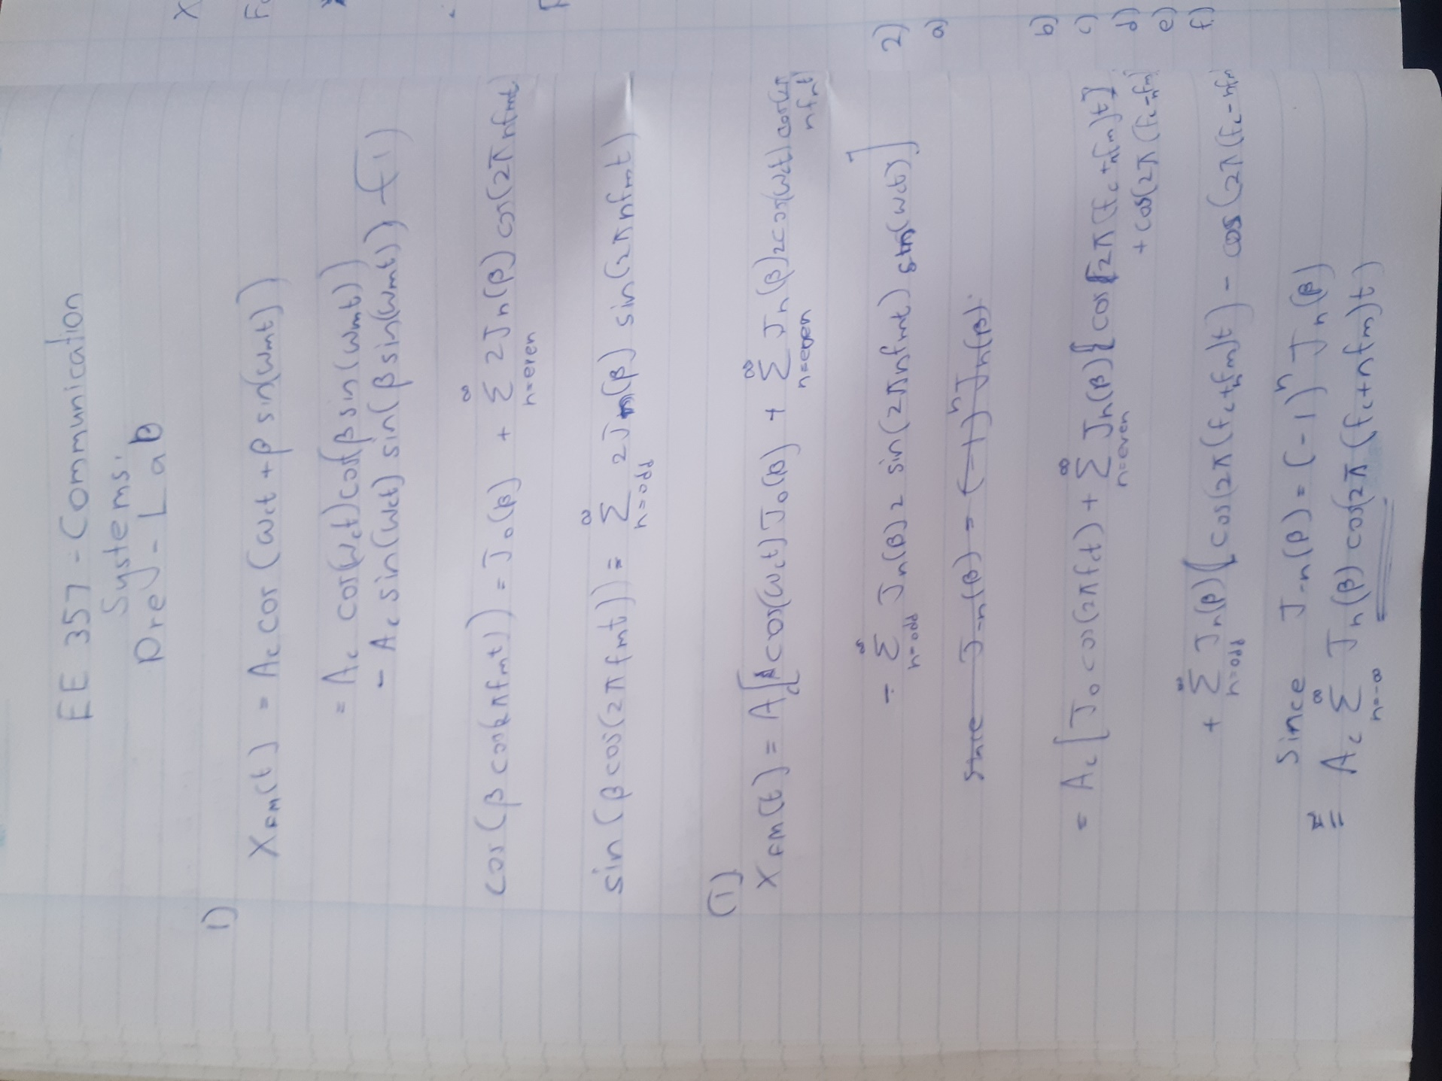

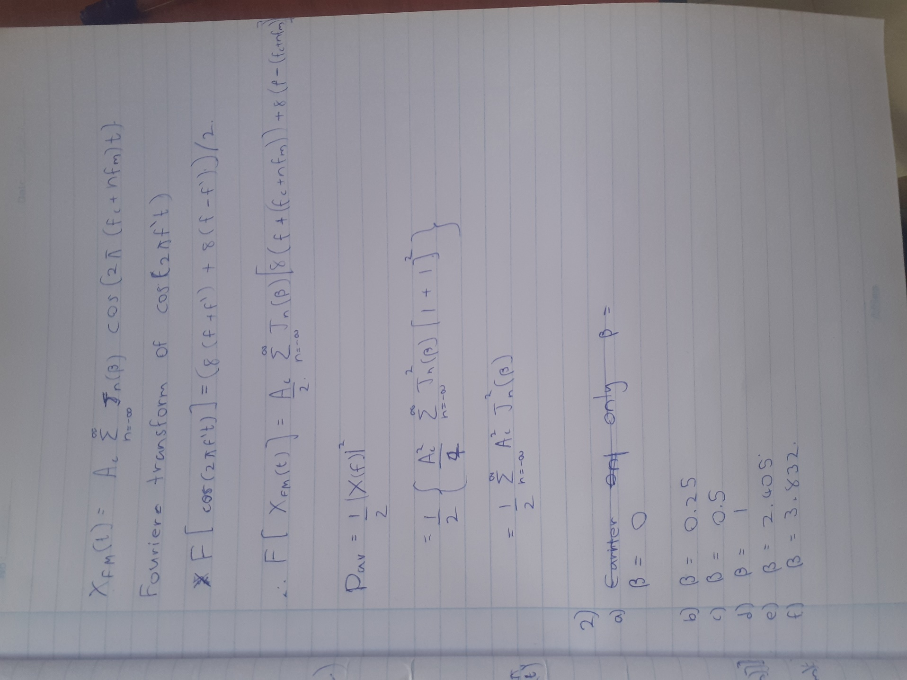

**Matlab Exercise**

**Part 1-Generate different frequency modulated signal which has different frequency spectrums for the same message signal**

Fm - Frequency of the messege signal

Fc - Frequency of the carrier signal

Fs - Sampling Frequency (4 x(Fm+Fc))

Len - time interval (0 to10 secs)

fc =200;

fm =10;

kf=1;

Fs=4*fc;

L=1500;

t=(0:L)*(1/Fs);

f = Fs*(0:(L/2))/L;

% a) beta = 0

% b) beta = 0.25

% c) beta = 0.5

% d) beta = 1

% e) beta = 2.405 carrier is not present while others are present

% f) beta = 3.832 1st side band is not present while others are present

n = input('Enter a letter: ');

switch n

case 1

beta = 0;

Am = beta *fm/kf;

case 2

beta = 0.25;

Am = beta *fm/kf;

case 3

beta = 0.5;

Am = beta *fm/kf;

case 4

beta = 1;

Am = beta *fm/kf;

case 5

beta = 2.405 ;

Am = beta *fm/kf;

case 6

beta = 3.832;

Am = beta *fm/kf;

otherwise

disp('try again')

end

f1=figure;

f2=figure;

Xfm = cos(2*pi*fc*t + beta*sin(2*pi*fm*t));

figure(f1);

Y=abs(fftshift(fft(Xfm)));

plot(f,Y(1:L/2+1));

title(['(',num2str(n),') Fourier plot of Xfm(t) for Am = ',num2str(Am),'.']);

figure(f2);

plot(t(1:100),Xfm(1:100));

title(['(',num2str(n),') Time series plot of Xfm(t) for Am = ',num2str(Am),'.']);

**a) Carrier only.**

When Beta =0 , acording to Bessel table only carrier frequency gets multiplied with a non zero coefficient. Then Am=0

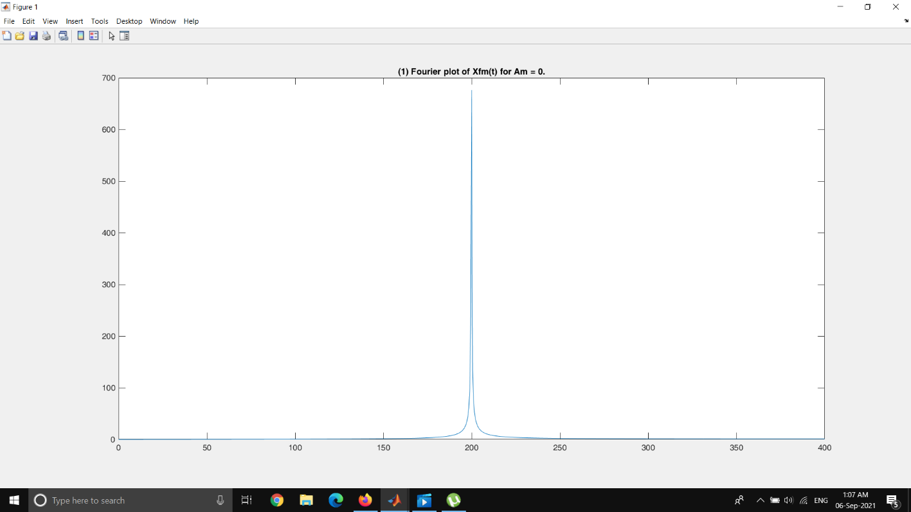

Figure 1 : FFT plot when Am = 0

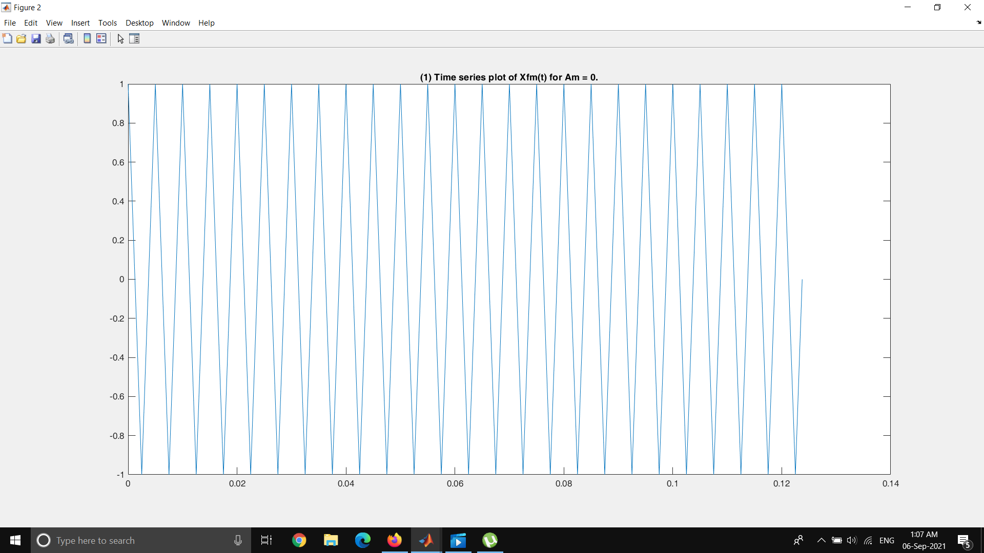

Figure 2 : Time series plot when Am = 0 (Only carrier frequency)

**b) Only the carrier and the 1st sideband pair are there.**

When Beta = 0.25 , acording to Bessel table only carrier frequency and 1st sideband gets multiplied with a non zero coefficient. Then Am = 2.5

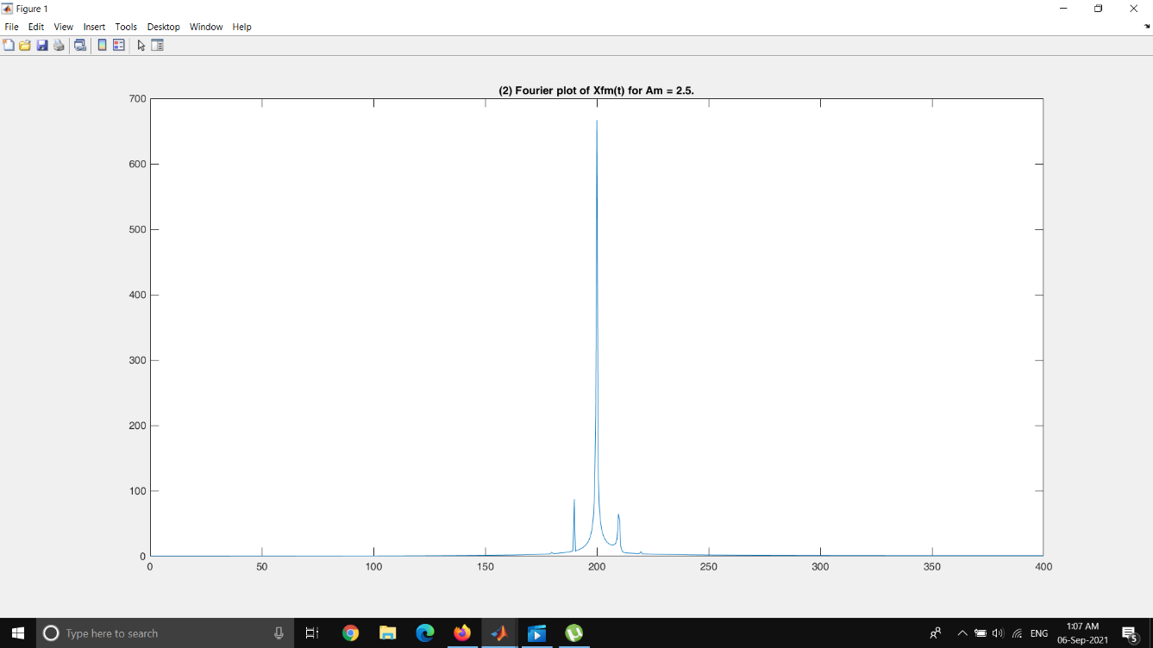

Figure 3 : FFT plot when Am = 2.5 (Only carrier frequency & 1st sideband)

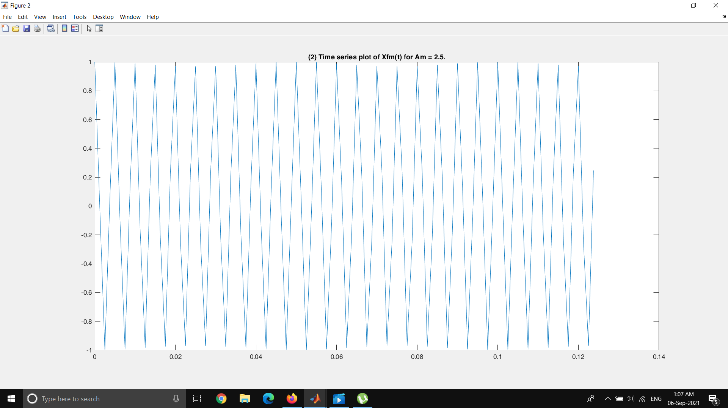

Figure 4 : Time series plot when Am = 2.5 (Only carrier frequency & 1st sideband)

**c) Only the carrier, 1st sideband pair and the 2nd sideband pair are there.**

When Beta = 0.5 , acording to Bessel table this condition is achieved. Then Am = 5

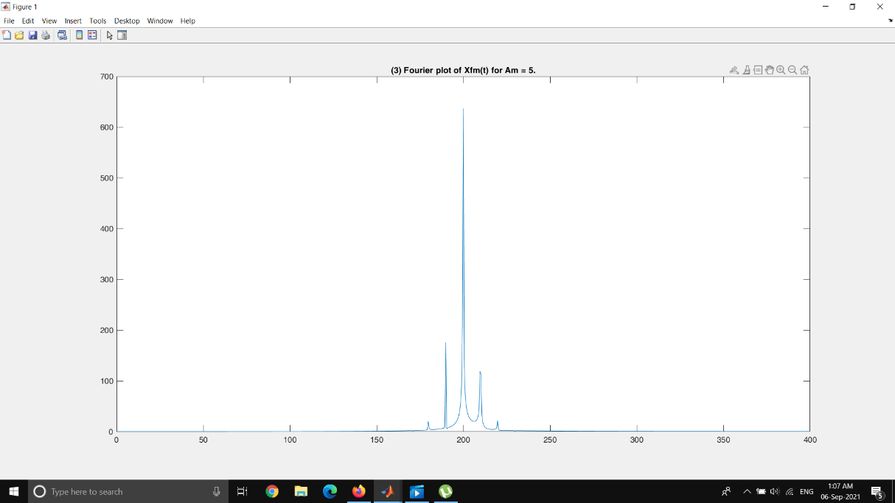

Figure 5 : FFT plot when Am = 5 (Only carrier frequency & 1st ,2nd sideband)

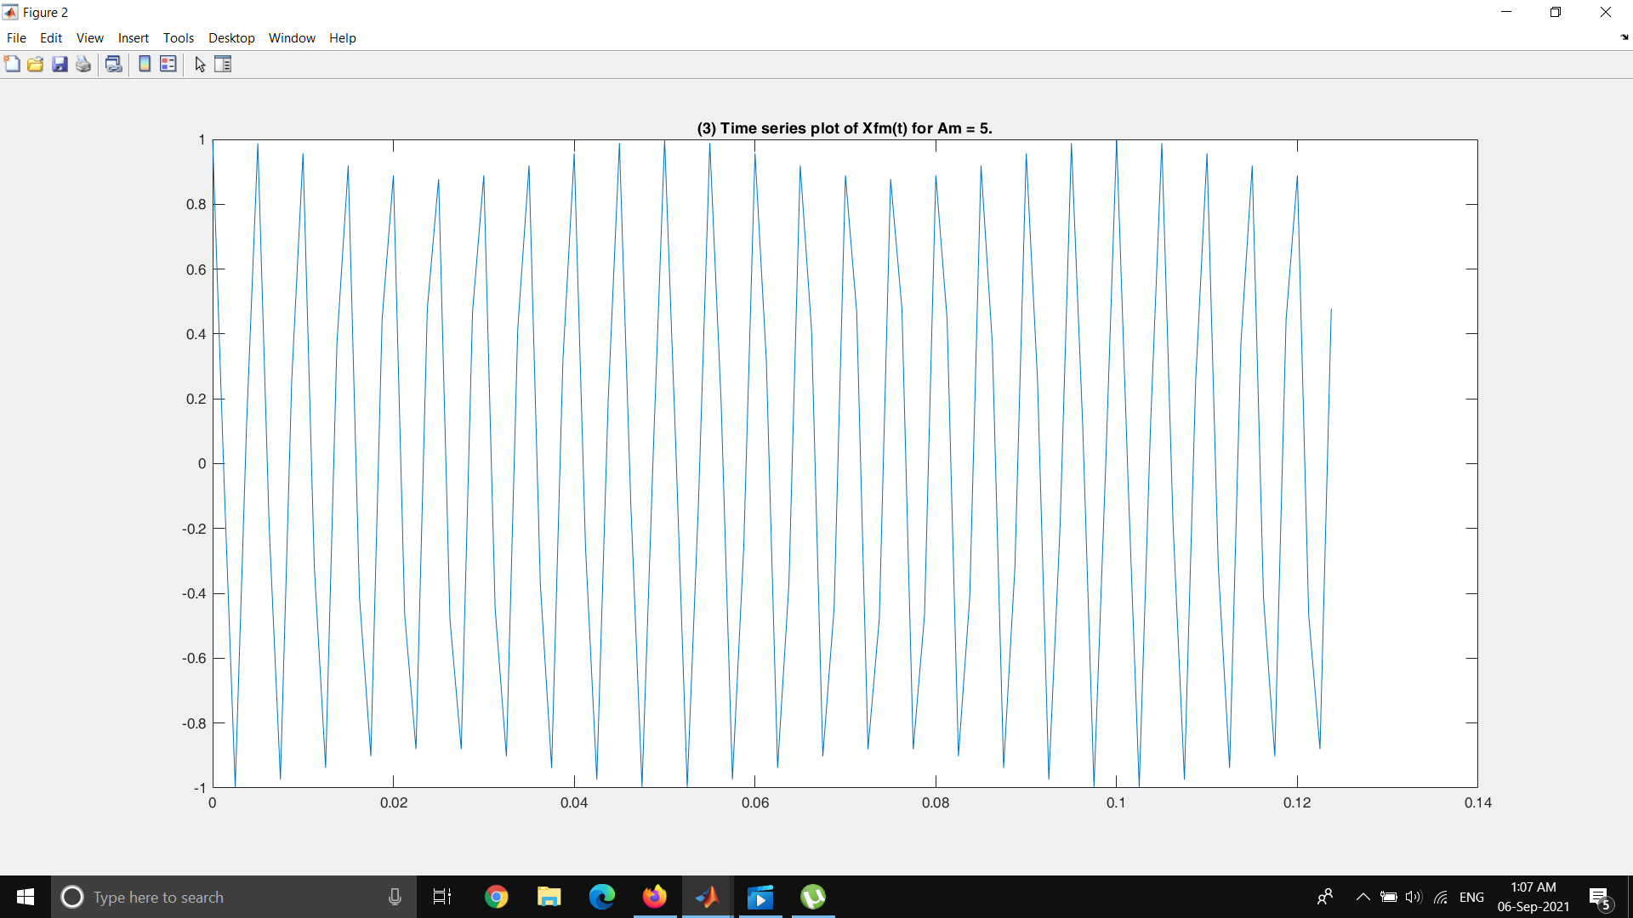

Figure 6 : Time series plot when Am = 5 (Only carrier frequency & 1st ,2nd sideband d)

**d) Only the carrier, 1st sideband pair the 2nd sideband pair and 3rd sideband**

**pair are there.**

When Beta = 1 , acording to Bessel this condition is achieved. Then Am = 10

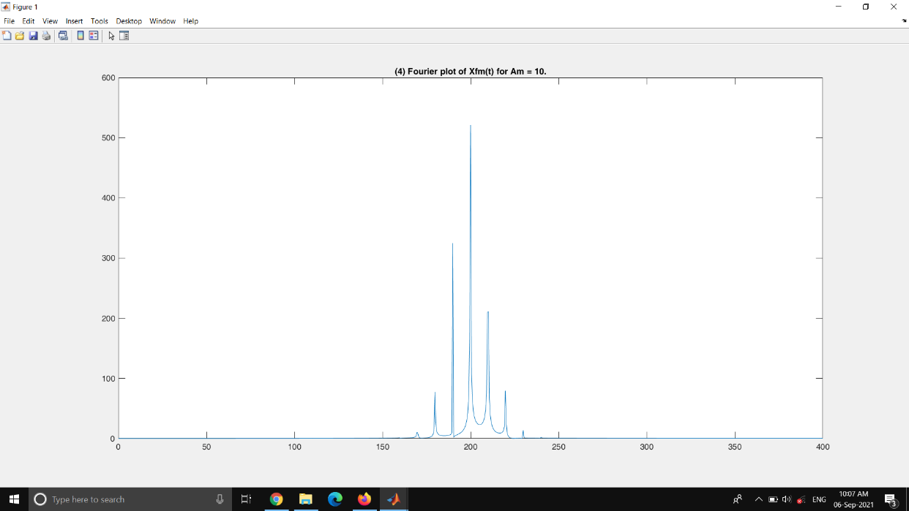

Figure 7 : FFT plot when Am = 16 (Only carrier frequency & 1st 2nd 3rd sideband)

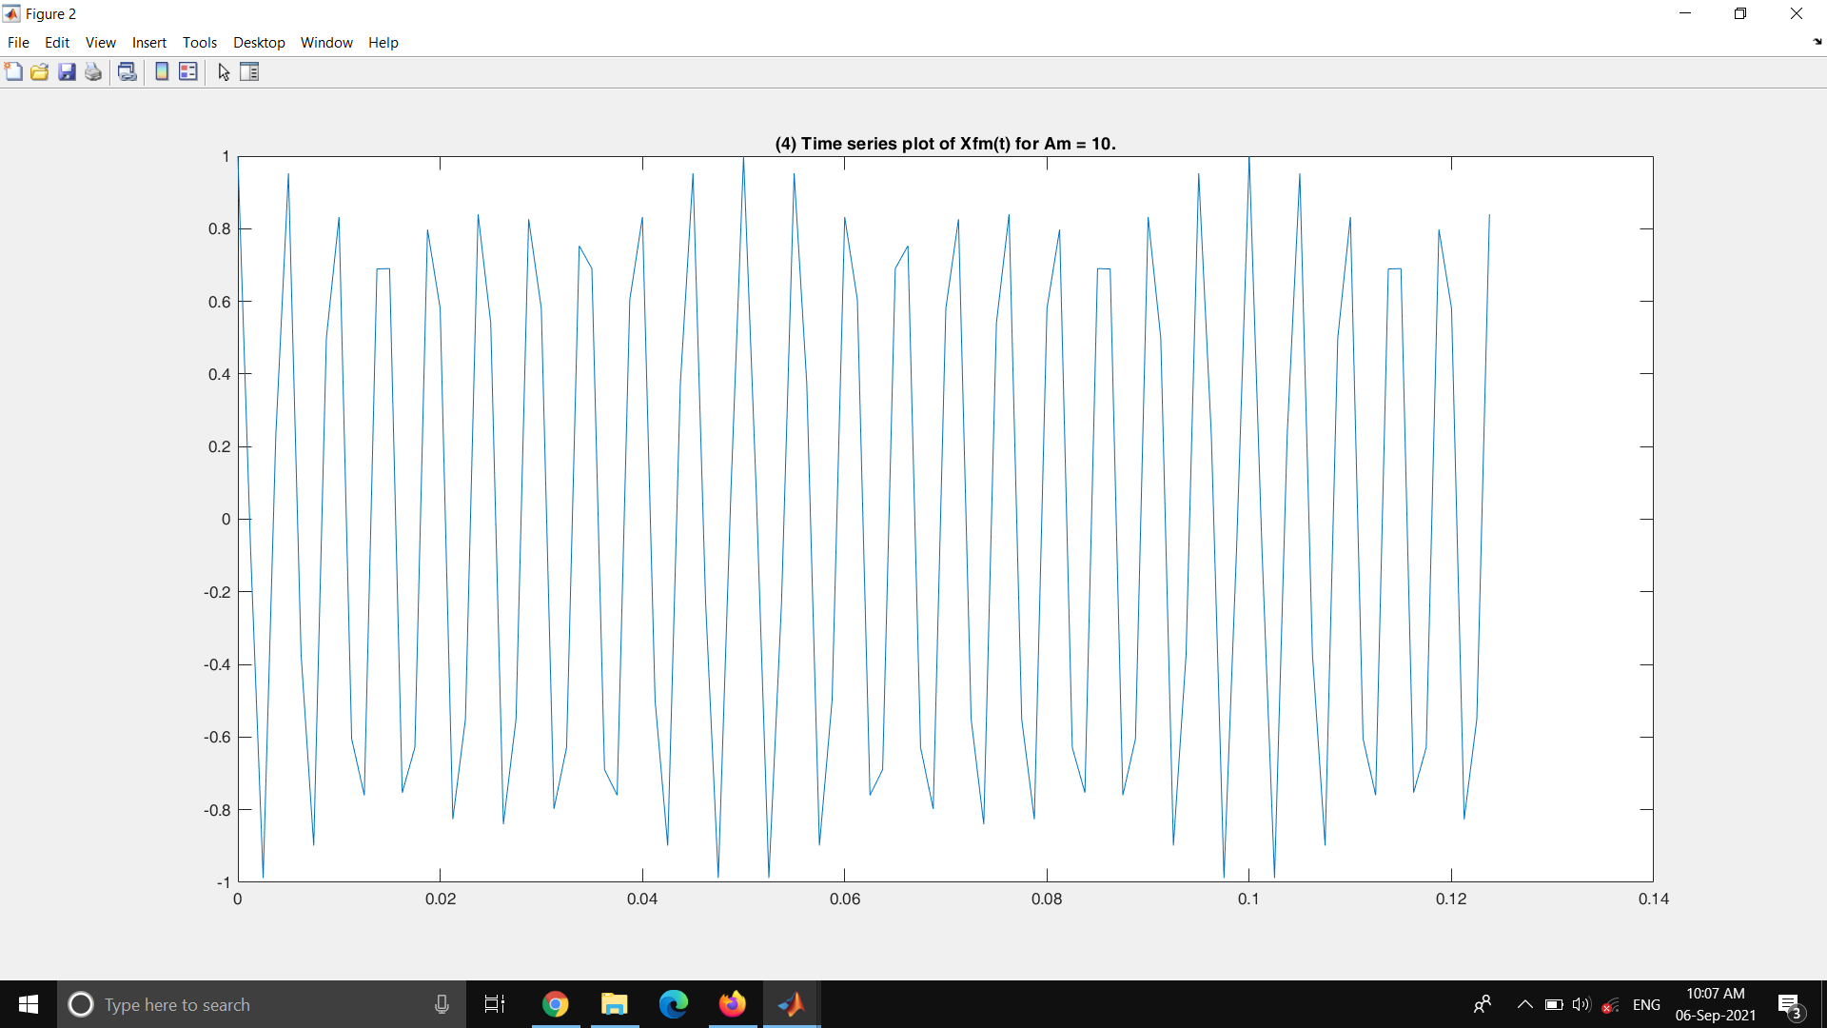

Figure 8 : Time series plot when Am = 16 (Only carrier frequency & 1st 2nd 3rd sideband)

**e) Suppressed carrier.**

When Beta = 2.405 , acording to Bessel table this condition is achieved. Then Am = 24.05

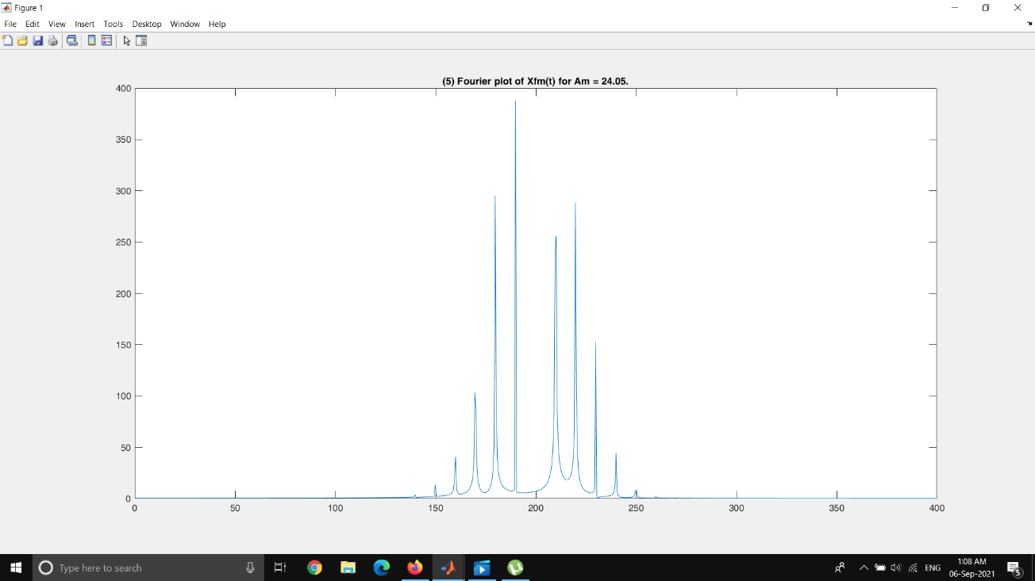

Figure 9 : FFT plot when Am = 24.05 (Suppressed)

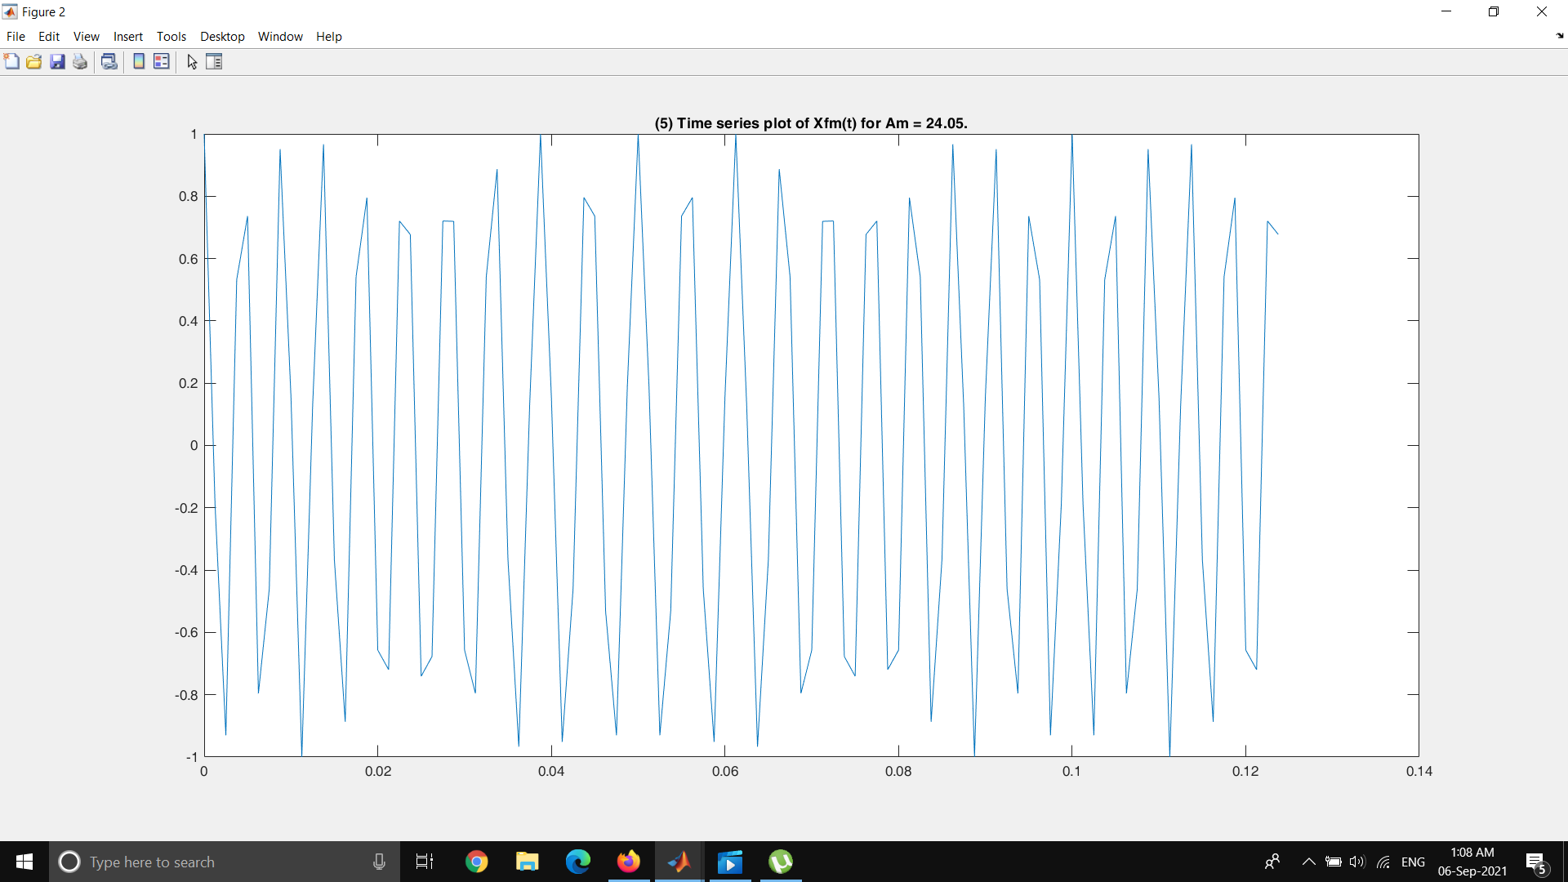

Figure 10 : Time series plot when Am = 24.05 (Suppressed)

**f) Suppressed 1st sideband pair.**

When Beta = 3.8 , acording to Bessel table this condition is achieved. Then Am = 38.32

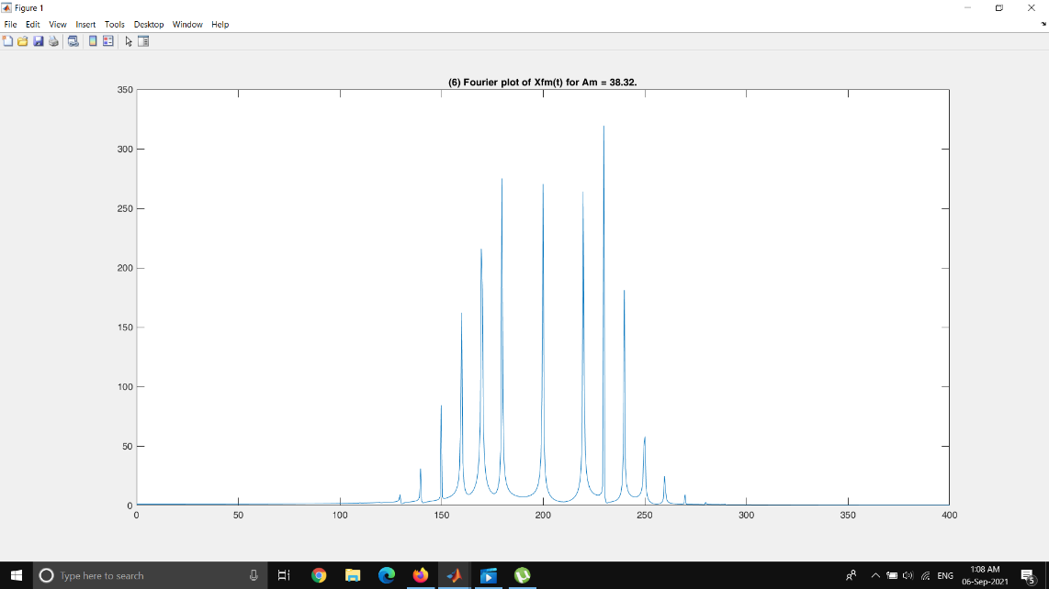

Figure 11 : FFT plot when Am = 38.32 (Suppressed 1st sideband)

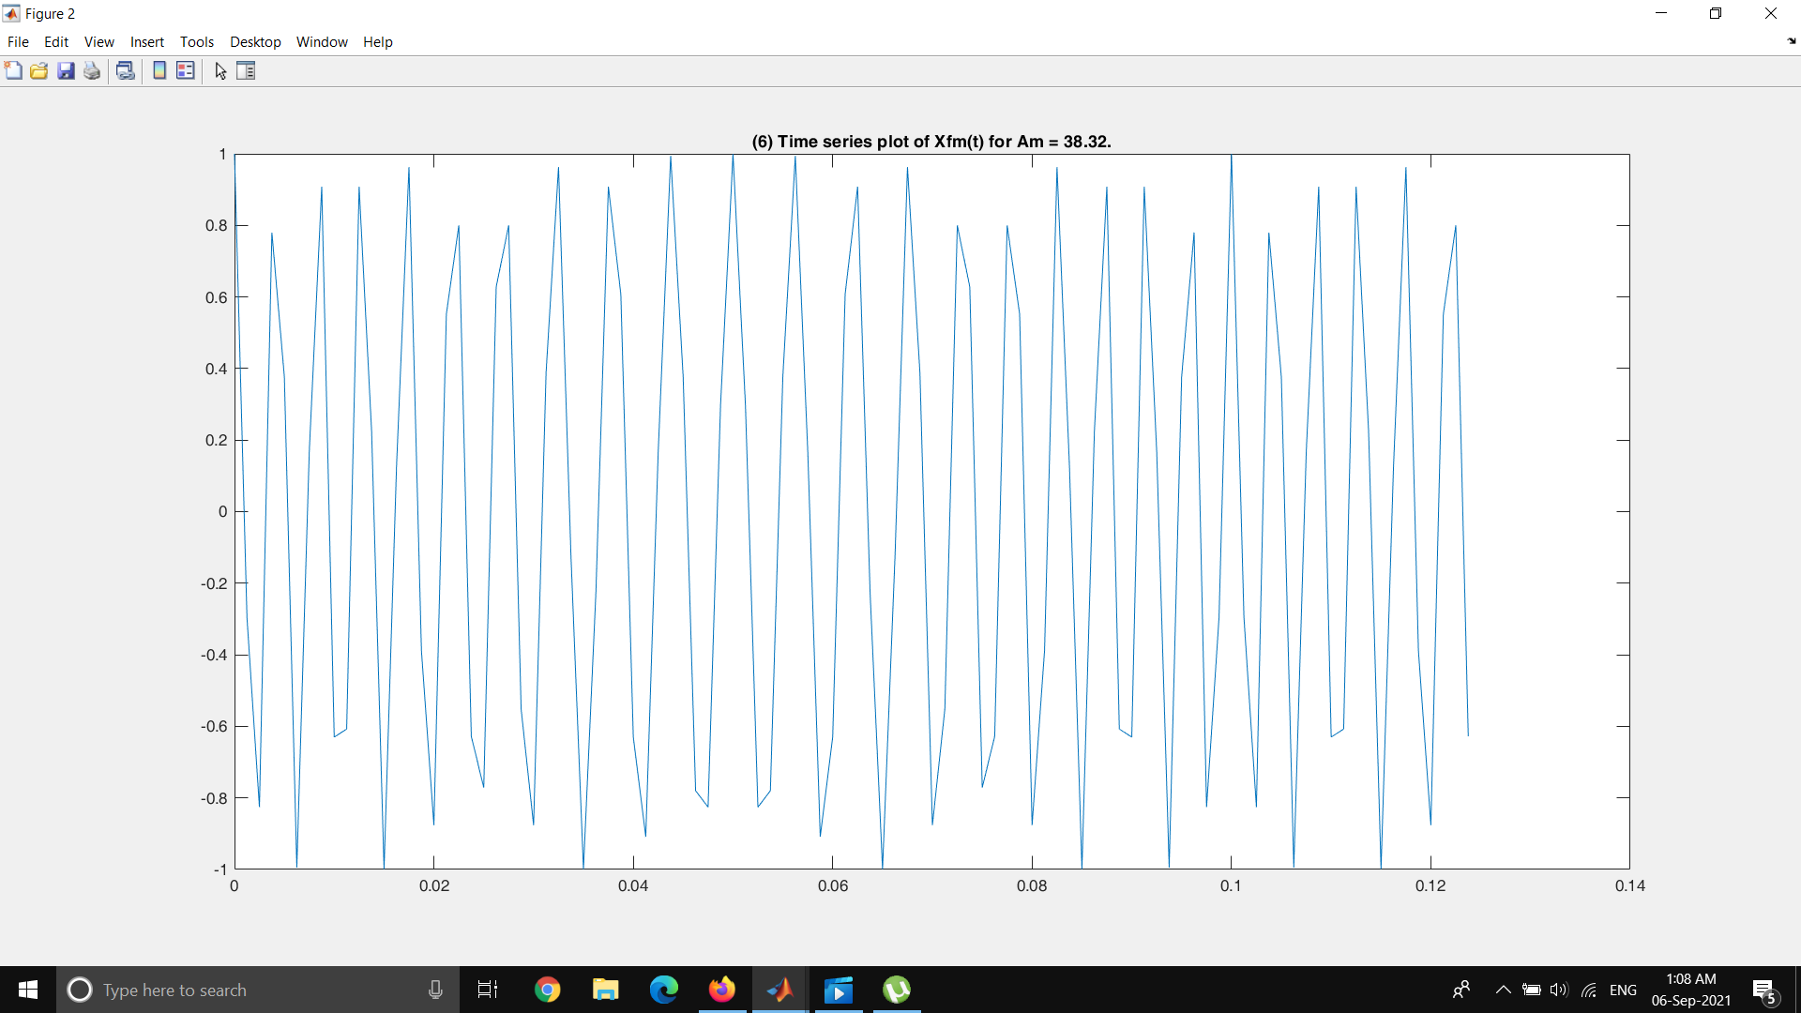

Figure 12 : Time series plot when Am = 38.32 (Suppressed 1st sideband)

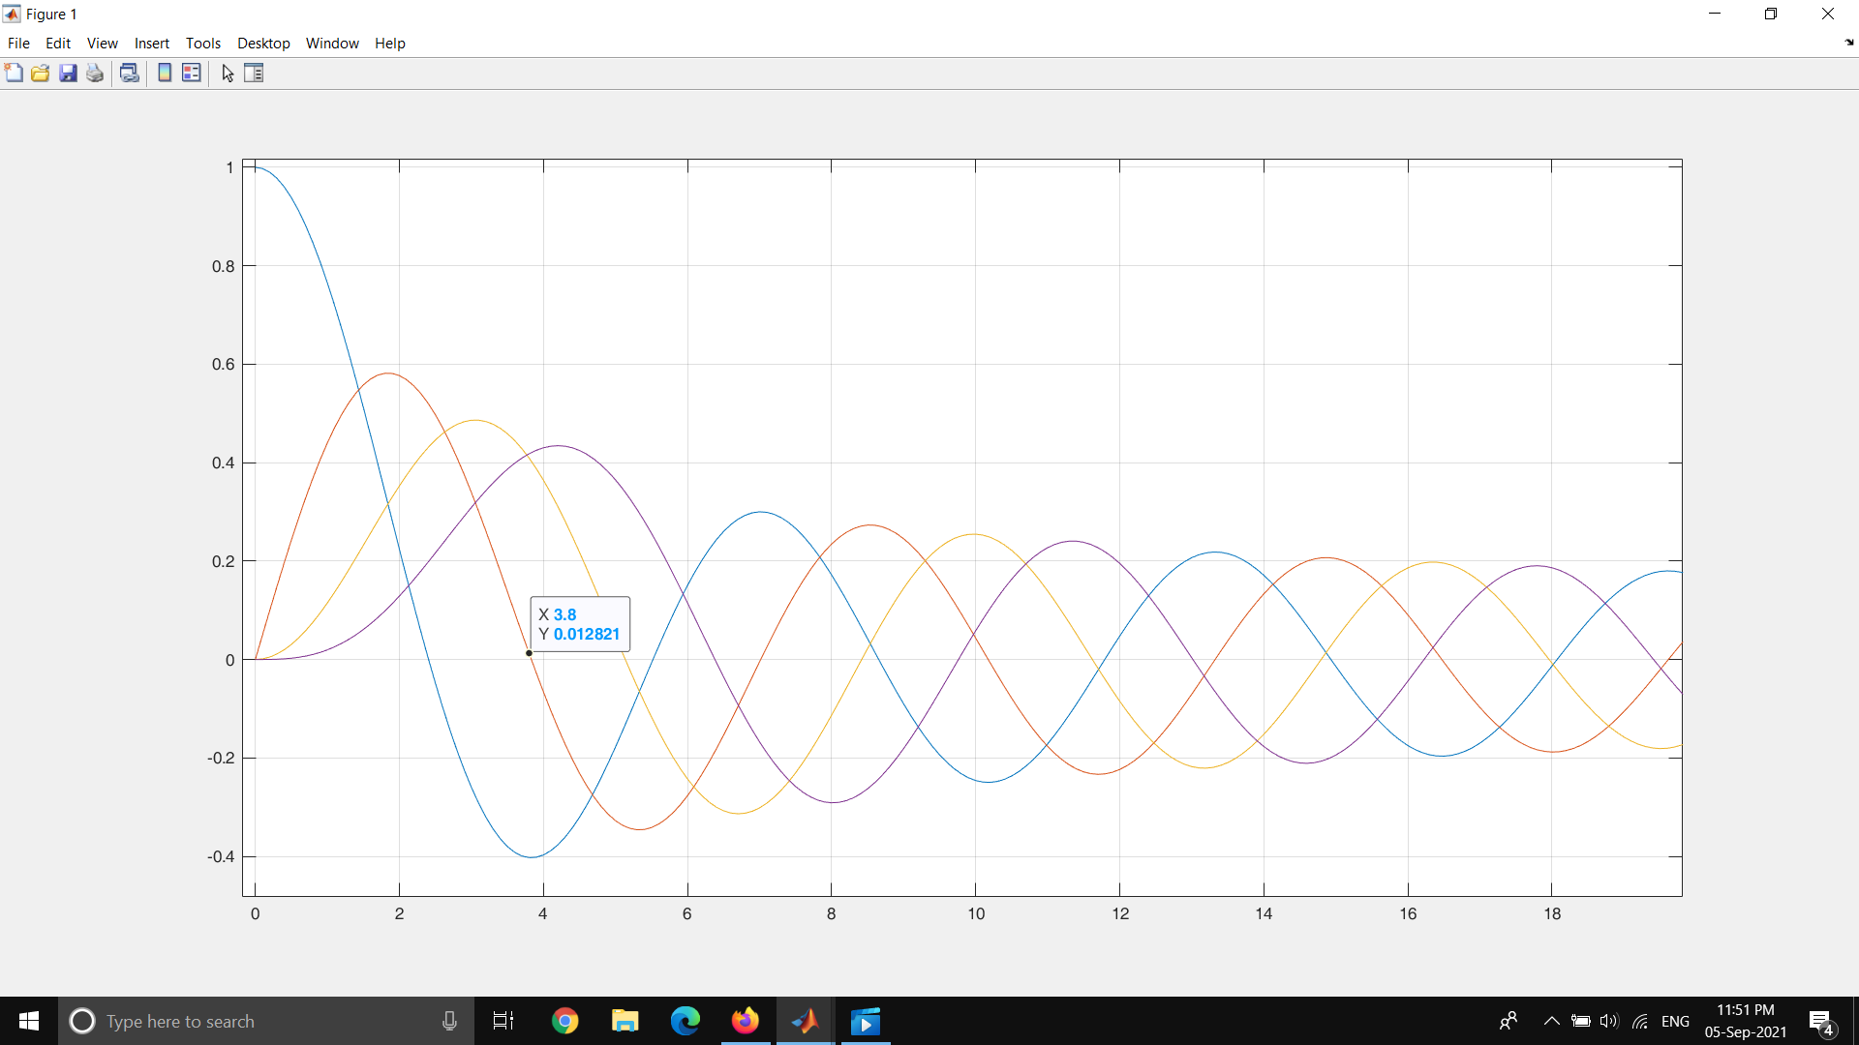

Figure 13 : Bessel Fuction at beta = 3.802

**Part 2 : Observe the effect of fm on the frequency spectrum**

fc =200;

fm =40;

kf=1;

Fs=4*fc;

L=1500;

t=(0:L)*(1/Fs);

f = Fs*(0:(L/2))/L;

beta = 4;

f1=figure;

f2=figure;

Xfm = cos(2*pi*fc*t + beta*sin(2*pi*fm*t));

figure(f1);

Y=abs(fftshift(fft(Xfm)));

plot(f,Y(1:L/2+1));

title(['(',num2str(n),') Fourier plot of Xfm(t) for fm = ',num2str(fm),'.']);

figure(f2);

plot(t(1:100),Xfm(1:100));

title(['(',num2str(n),') Time series plot of Xfm(t) for fm = ',num2str(fm),'.']);

Beta = 4

**Fm = 10 hz**

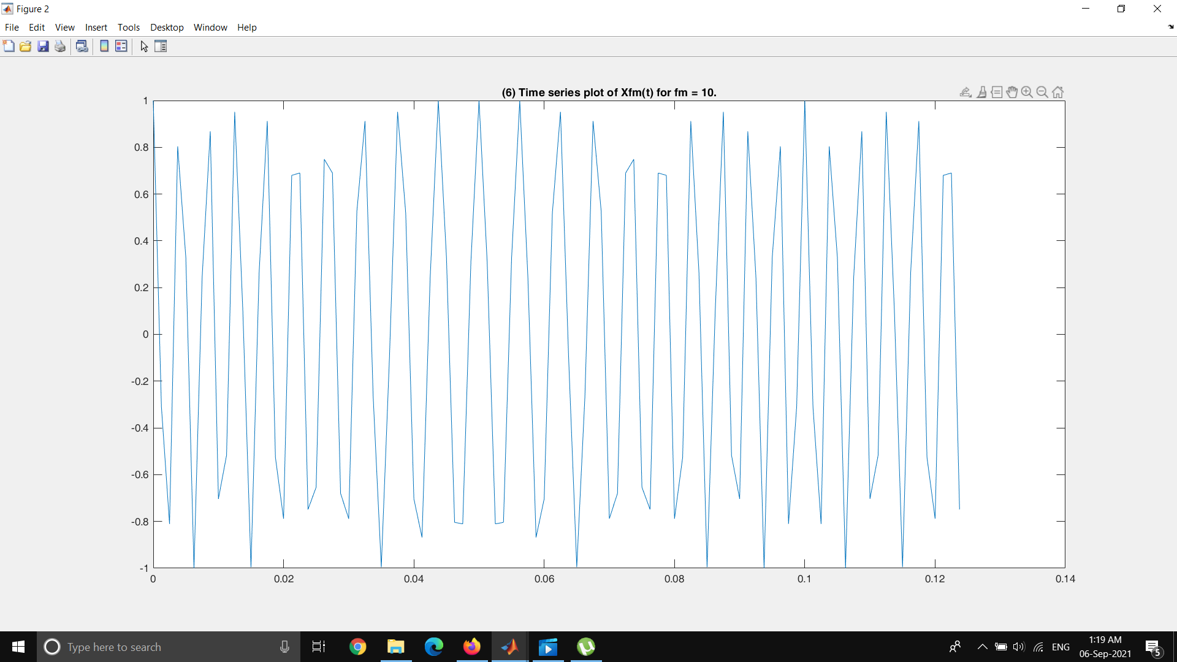

Figure 14 : Time Series plot of FM signal for fm= 10 Hz

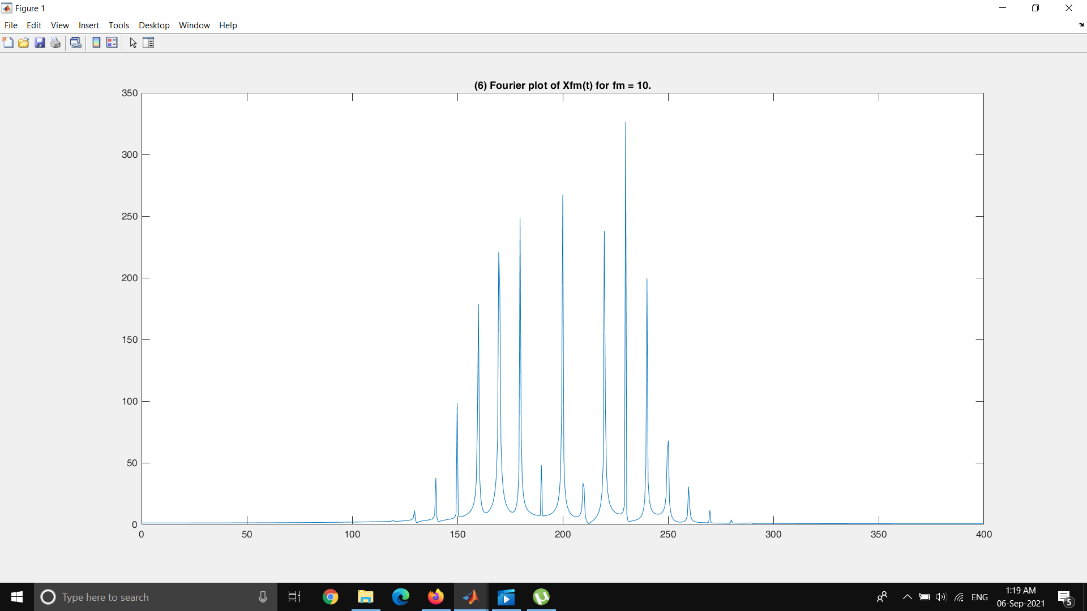

Figure 15 : FFT plot of FM signal for fm= 10 Hz

**Fm = 20 hz**

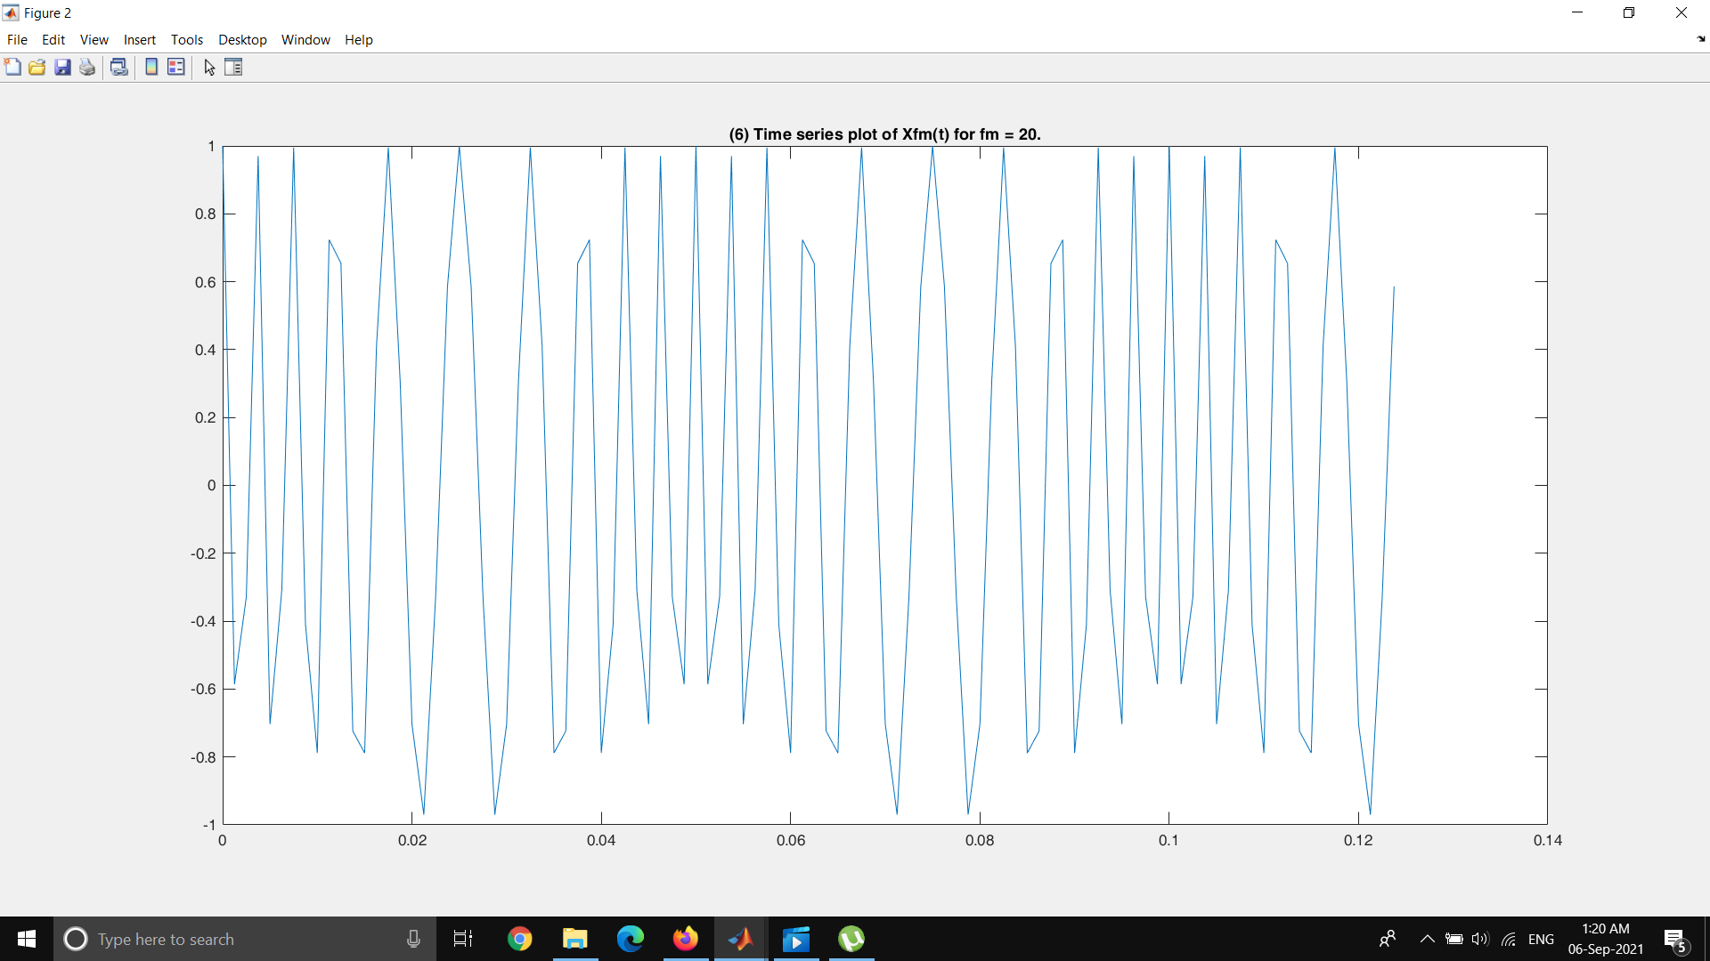

Figure 16 : Time Series plot of FM signal for fm= 20 Hz

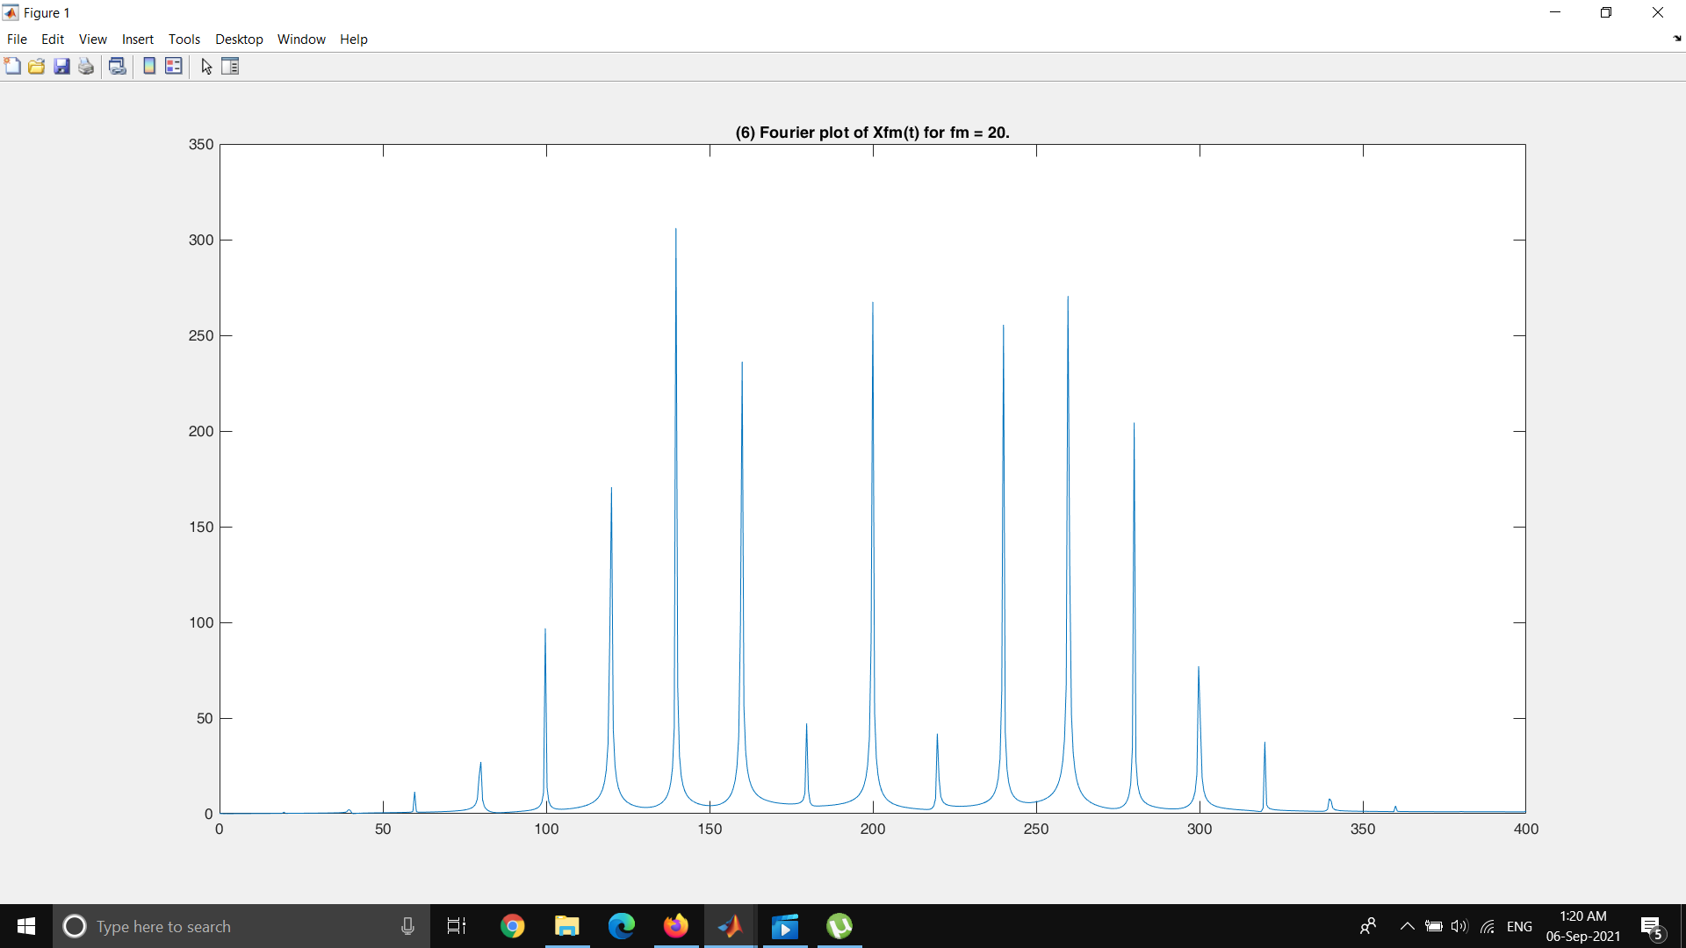

Figure 17 : FFT plot of FM signal for fm= 20 Hz

**Fm = 30 hz**

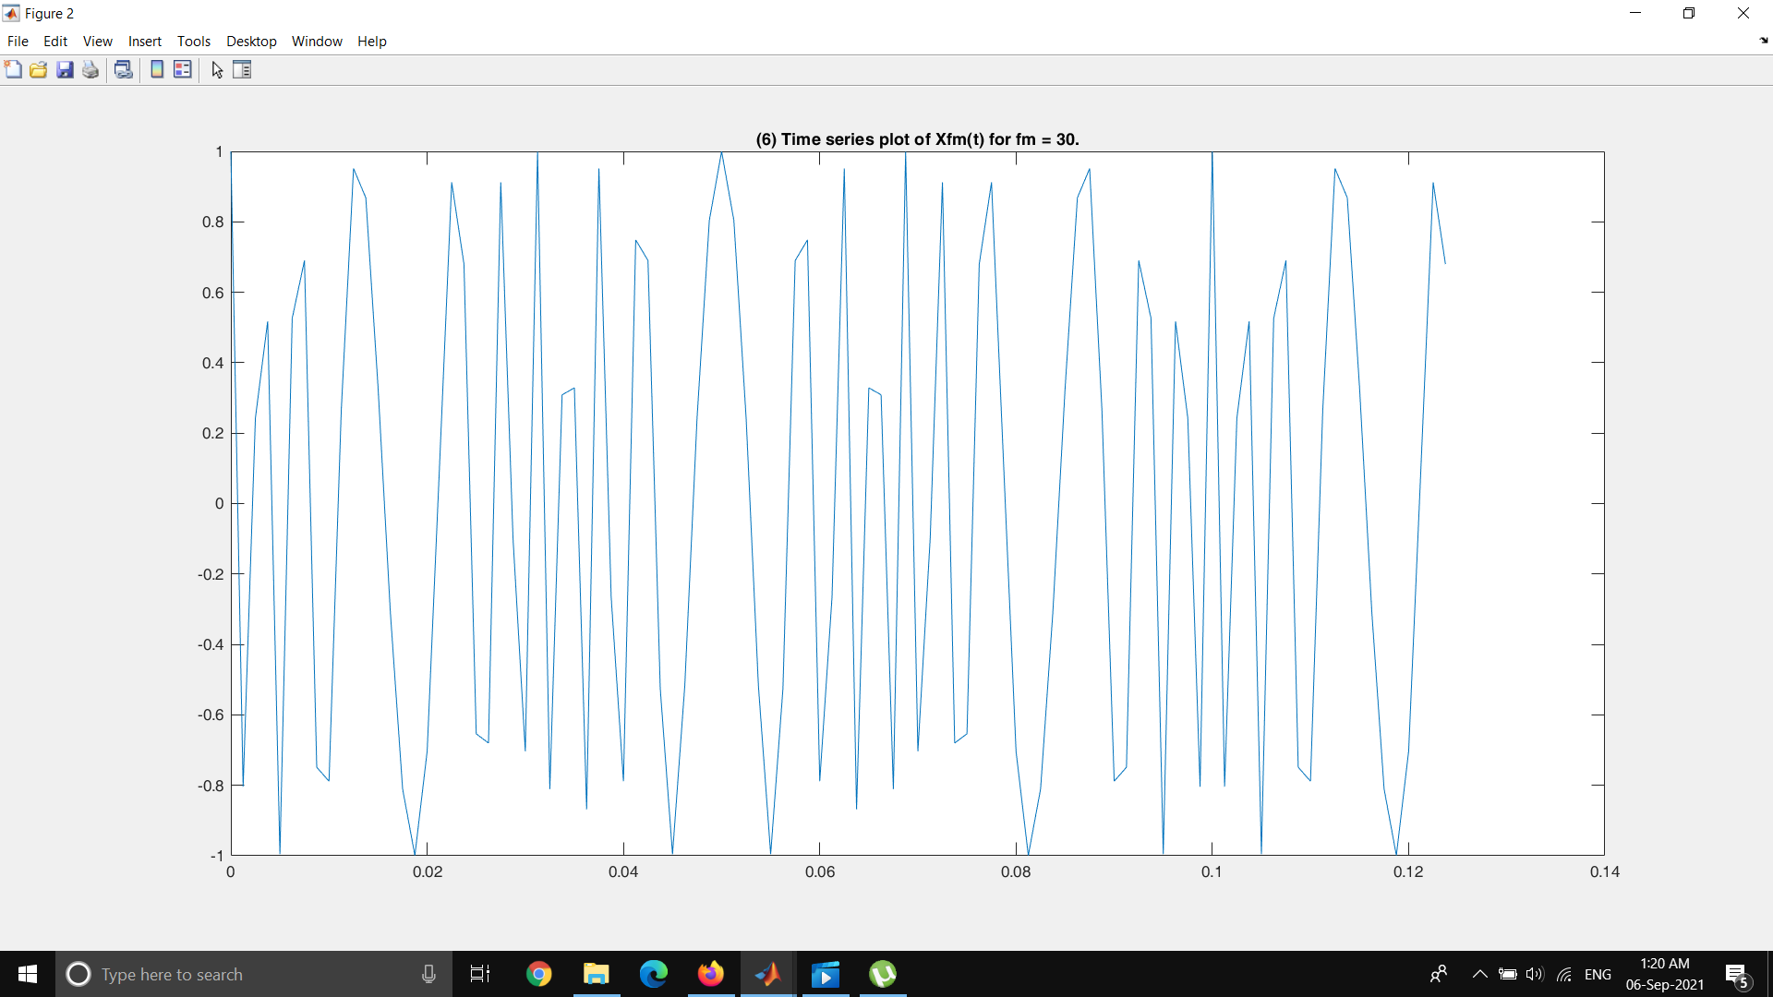

Figure 18 : Time Series plot of FM signal for fm= 30 Hz

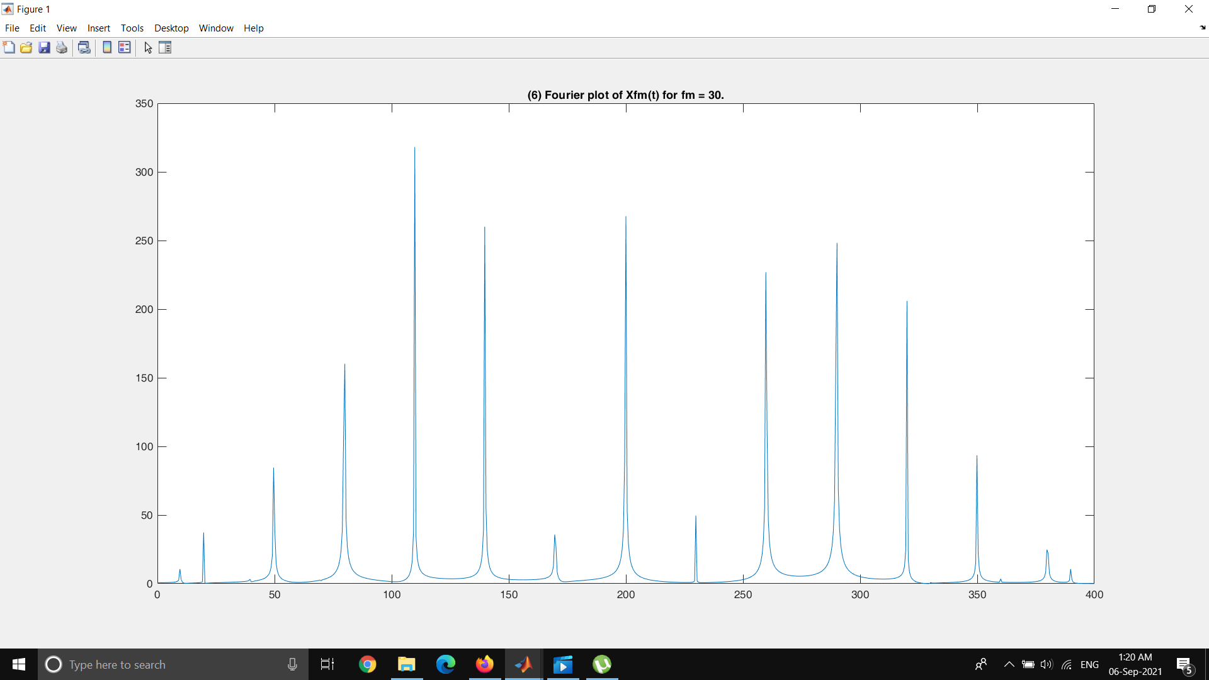

Figure 19 : FFT plot of FM signal for fm= 30 Hz

**Fm = 40 hz**

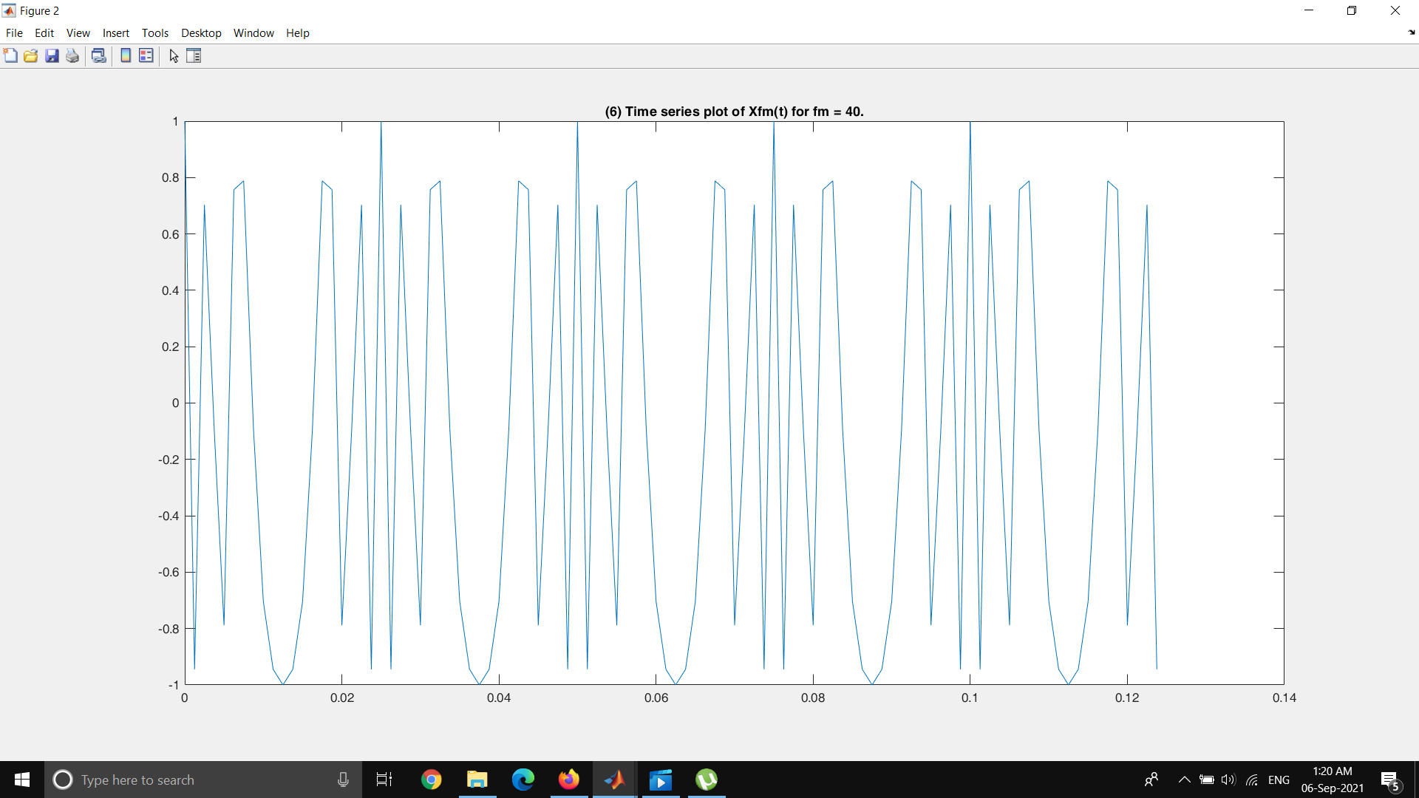

Figure 20 : Time Series plot of FM signal for fm= 40 Hz

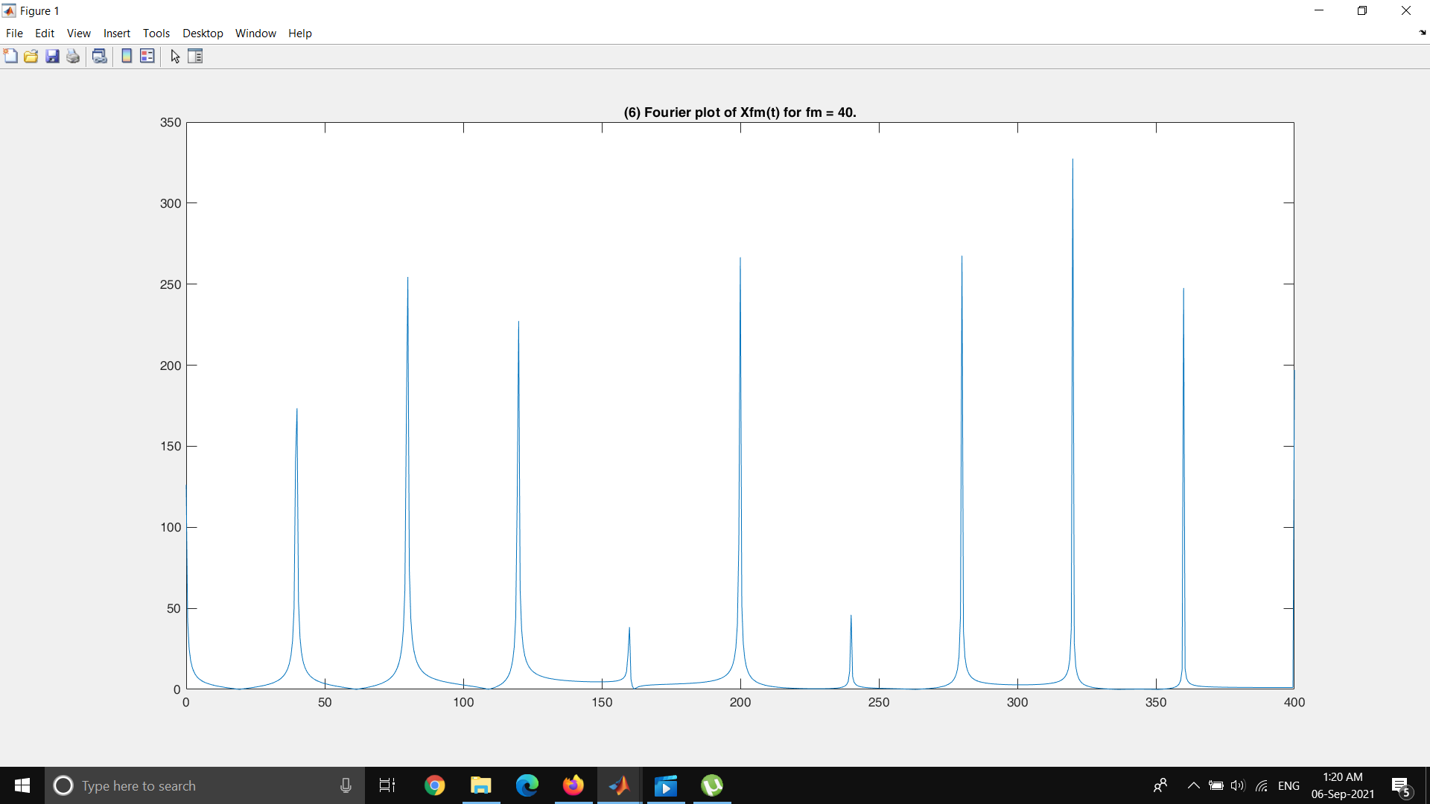

Figure 21 : FFT plot of FM signal for fm= 40 Hz

**DISCUSSIONS**

1. Explain why FM is better than AM in terms of resistance to noise.

In AM , interference can affect the signal because by adding noise the amplitude of the signal can be easily changed. Since in AM modulation the envelop carved in to the carrier signal contains the message when there is noise the amplitude of the AM signal is easily affected. Thus AM is vulnerable to noise.But in FM the instantaneous frequency carries the data. Tus FM is resistant to noise.

2. Describe two methods to estimate the occupied bandwidth of an FM signal.

Narrowband Fm - β is small compared to one radian

Wideband Fm - β is large compared to one radian

3. Describe the key features of spectrum allocation used for typical FM radio broadcasting.

In Frequency domain of an FM signal ideally frequency components go up to infinity while reducing its amplitude. Because of that one way used to determine the bandwidth is that frequency components which has amplitude less than a certain threshold is neglected.Other method is the Carson’s rule.

4. Compare the performance of FM and AM on the frequency spectrum.

AM signal has a smaller bandwidth compared to FM signal.FM is more resistant to noise.

**FM DEMODULATION**

**Baseband Delay FM Demodulation**

fm = 1000; %1kHz

fc = 100000; %100kHz

Fs = 20*fc;

L = 100000;

t = (0:L)*(1/Fs);

beta = 1;

Am = beta*fm; %assume kf=1

mt = Am*cos(2*pi*fm*t);

Xfm = cos(2*pi*fc*t + beta*sin(2*pi*fm*t));

f = Fs*(0:(L/2))/L;

yi = Xfm.*cos(2*pi*fc*t);

yq = Xfm.*sin(2*pi*fc*t);

yiTild = lowpass(yi,2*fm,Fs);

yqTild = lowpass(yq,2*fm,Fs);

y = complex(yi,yq);

vn = angle(y.*conj(circshift(y,1)) ); %b=abs(fft(Xfm));

%plot(f,b(1:L/2+1))

f1=figure;

f2=figure;

figure(f1);

phi=abs(fftshift(fft(vn)));

plot(f,phi(1:L/2+1));

title(' Fourier plot of recovered m(t) from baseband delay f modulator.');

figure(f2);

plot(t(1:100),vn(1:100));hold on;plot(t(1:100),mt(1:100),'r');legend('recovered mt','original mt')

title('Time series plot of recovered m(t) from baseband delay f modulator.');

Message Signal = 0.01sin(2π*1000*t)

Carrier Frequency = 100kHz

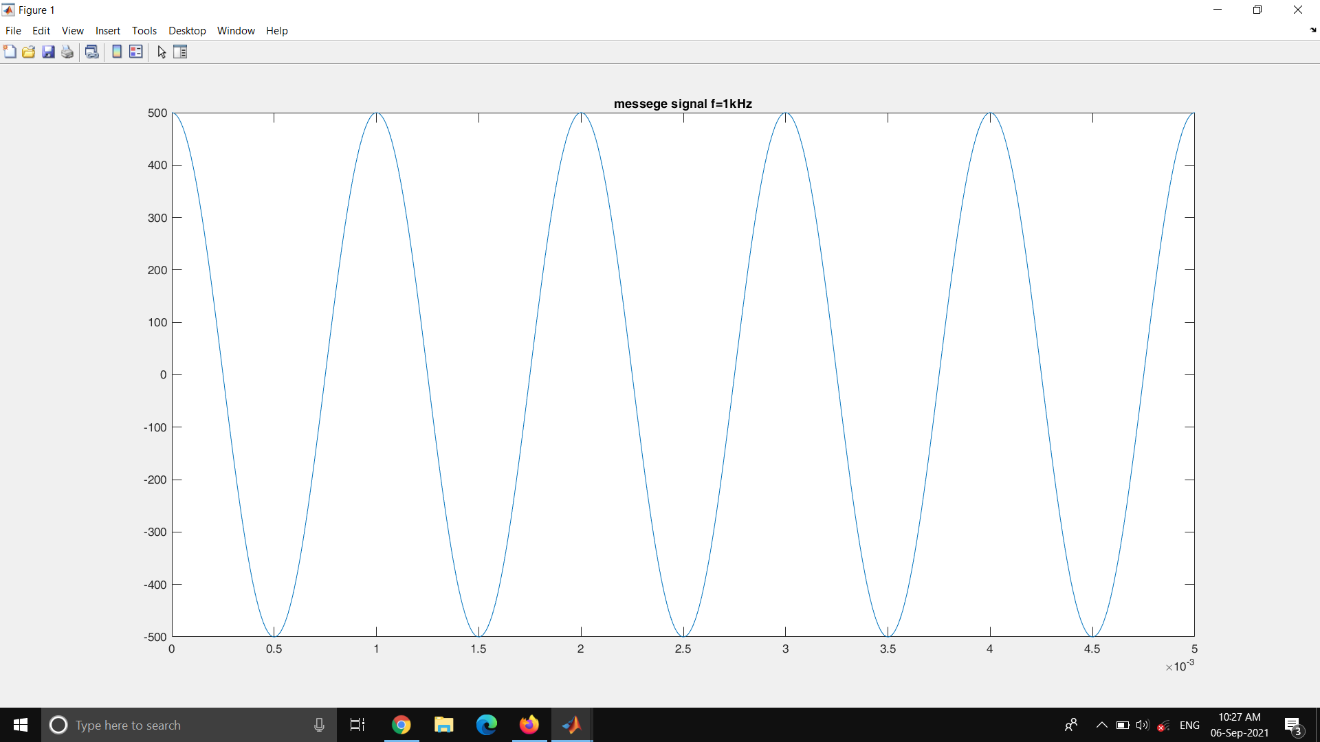

Figure 22 : Message Signal (1kHz)

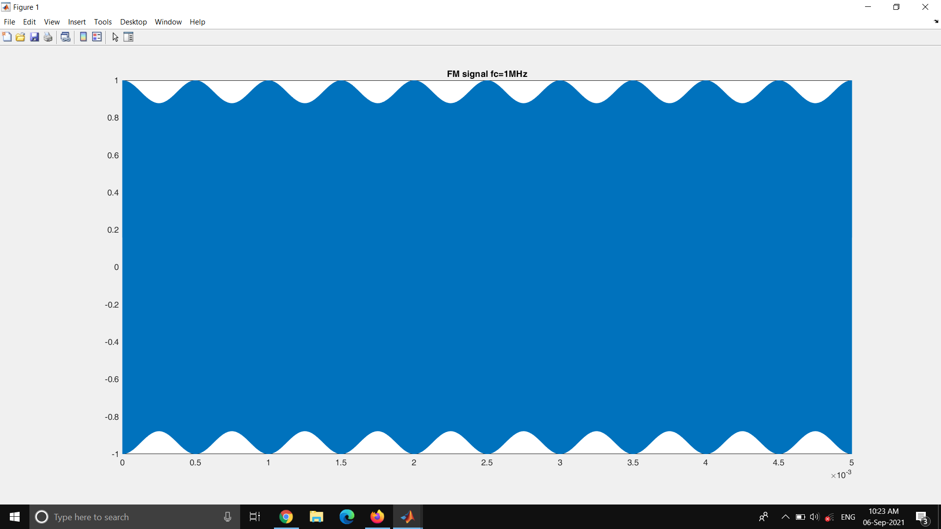

Figure 23 : FM signal

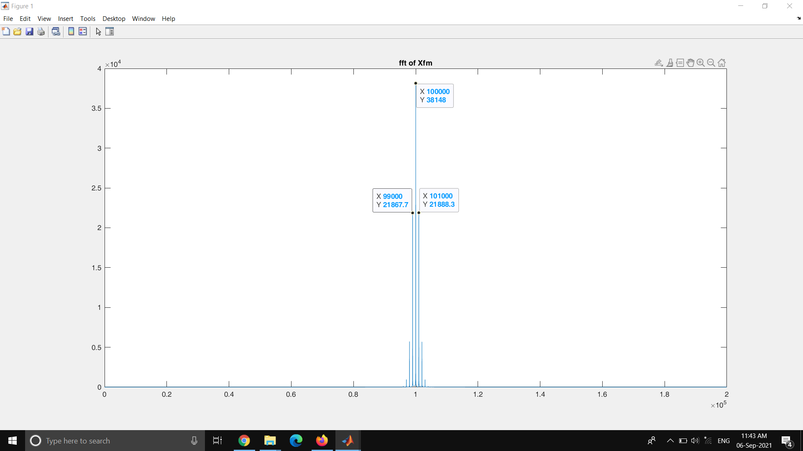

Figure 24 : Frequency plot of the FM signal

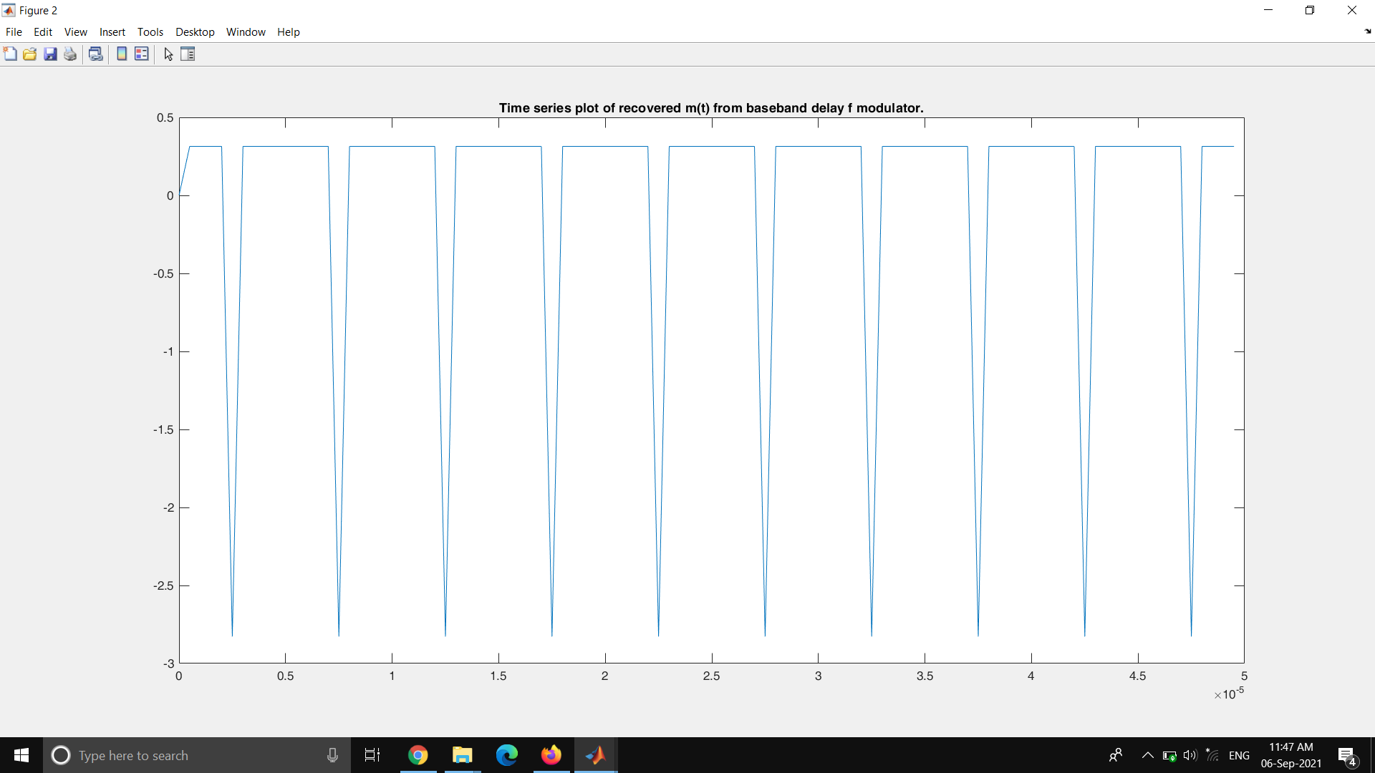

Figure 25 : Demodulated Time series plot ( bass band delay method)

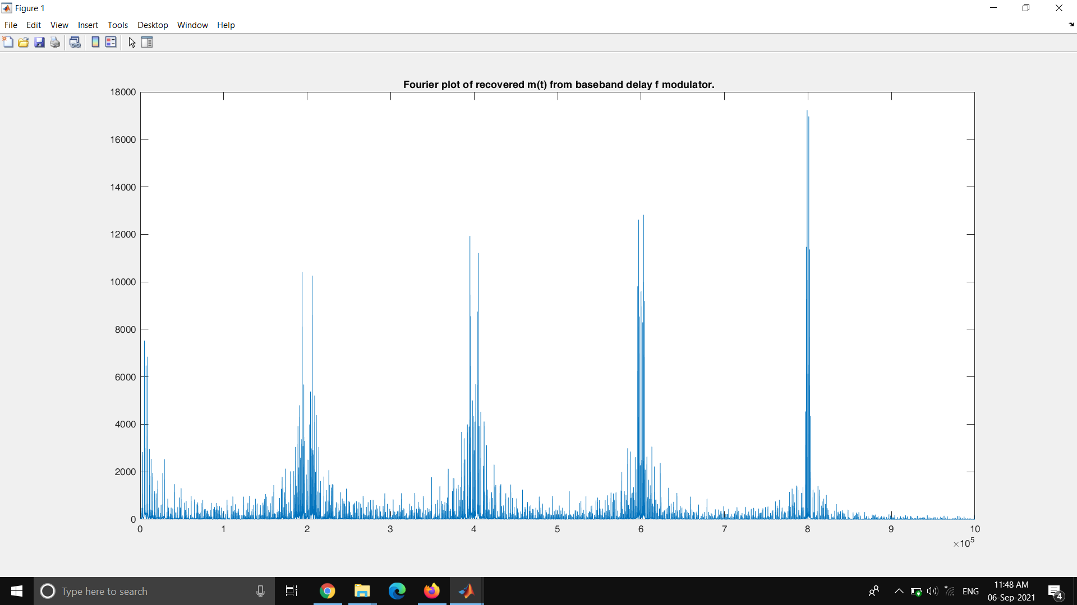

Figure 26 : Fourier lot of the recovered signal

**Demodulation Using Differentiation**

fm = 1000; %1kHz

fc = 100000; %100kHz

Fs = 20*fc;

L = 100000;

t = (0:L)*(1/Fs);

Am = .01;

kf = 1;

mt = Am*cos(2*pi*fm*t);

f = Fs*(0:(L/2))/L;

%rectpulse

% d = 0 : 1/fm : t(end);

% x = Am*rectpuls(t,0.0005);

% mt = pulstran(t,d,x,Fs);

imt = cumtrapz(mt);

Xfm = cos(2*pi*fc*t + 2*pi*kf*imt);

Df = gradient(Xfm);

%plot(t(1:10000),Xfm(1:10000));hold on;

[up,lo] = envelope(Df);

% hold on;

% plot(t(1:10000),up(1:10000),t(1:10000),lo(1:10000),'linewidth',1.5);

% title('FM signal vs envelop');

% legend('FM signal','up','lo');

% hold off;

m = mean(up);

plot(t(1:10000),up(1:10000)-m);hold on;title('time plot of recovered signal m(t)-sinusoidal')

% b = abs(fft(up-m));

% plot(f,b(1:L/2+1));hold on;title('fft of recovered signal m(t)')

Message Signal = 0.01sin(2π*1000*t)

Carrier Frequency = 100kHz

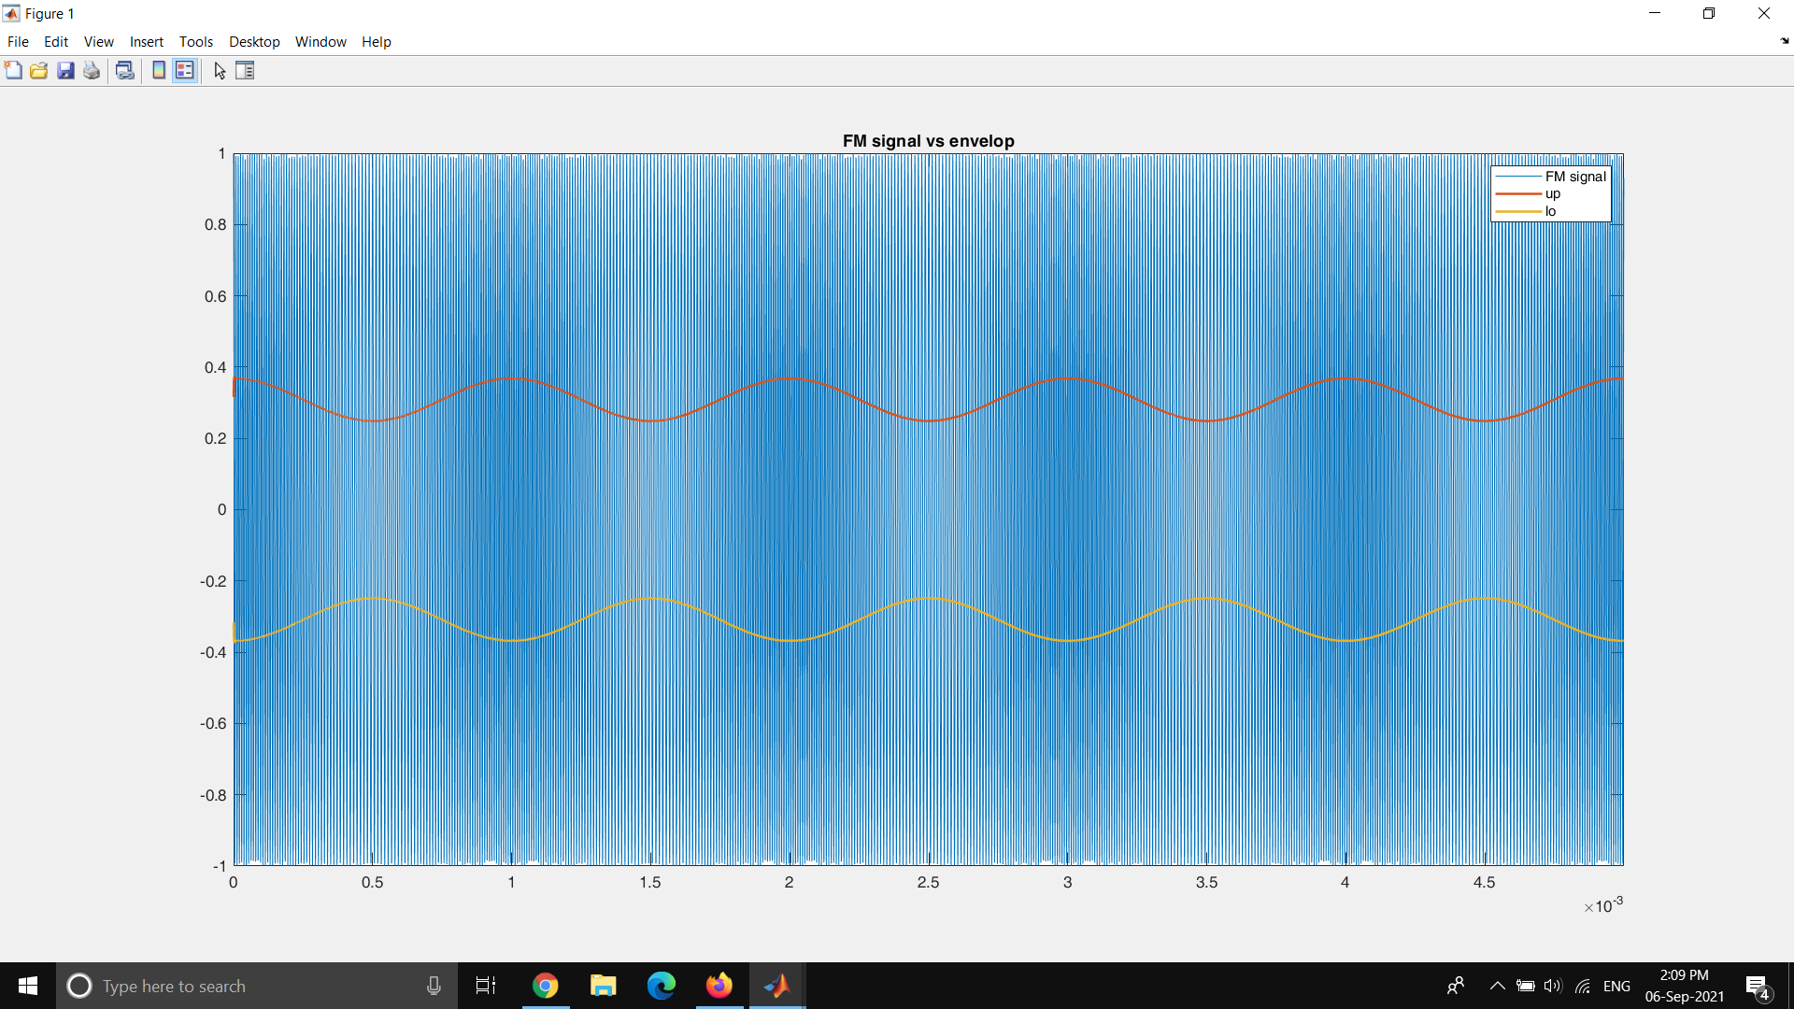

Figure 27 : Time Series plot of the FM signal and the envelop detected

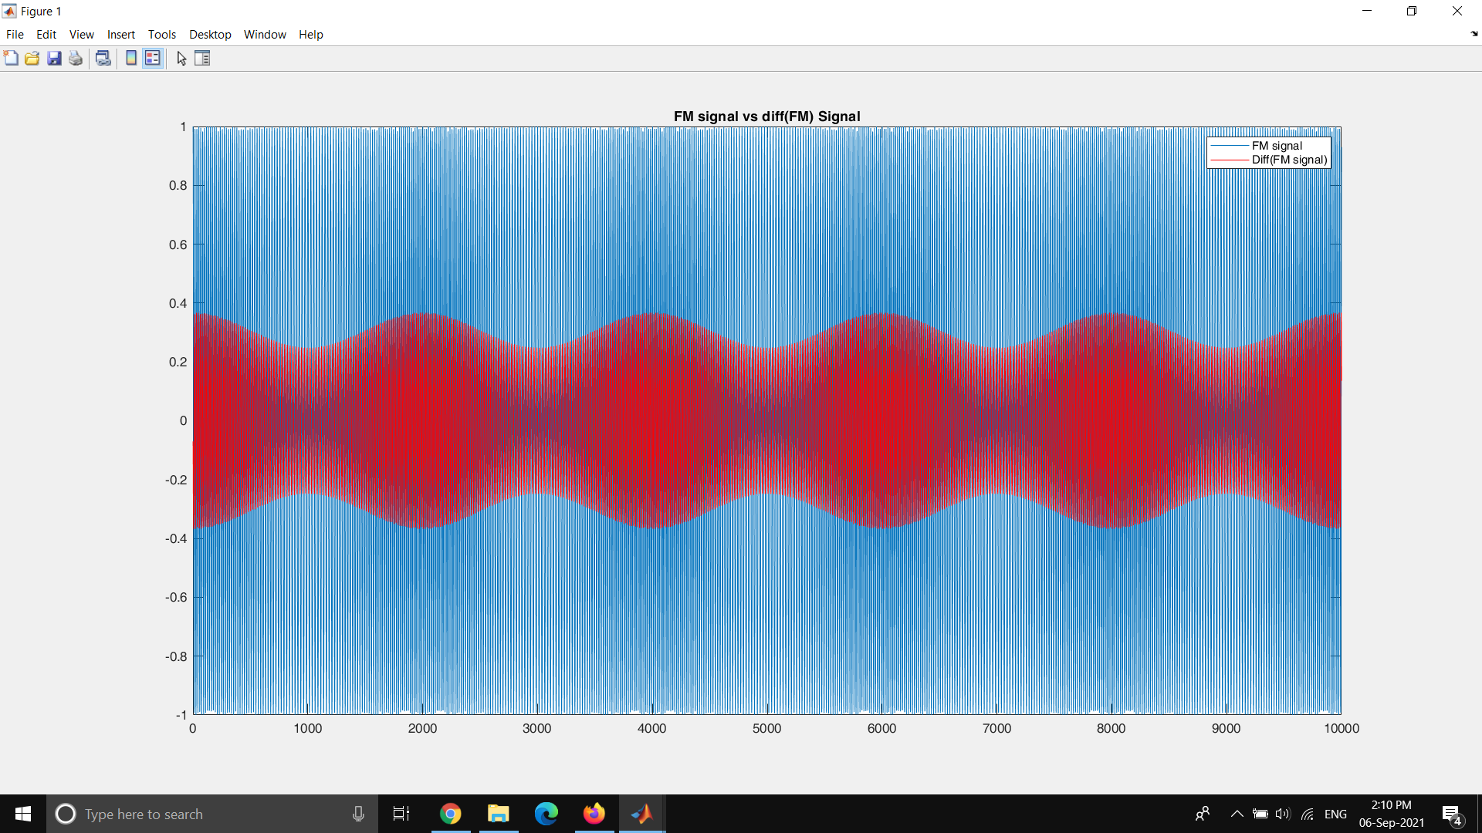

Figure 28 : Time Series plot of the FM signal and the differenciated Fm signal

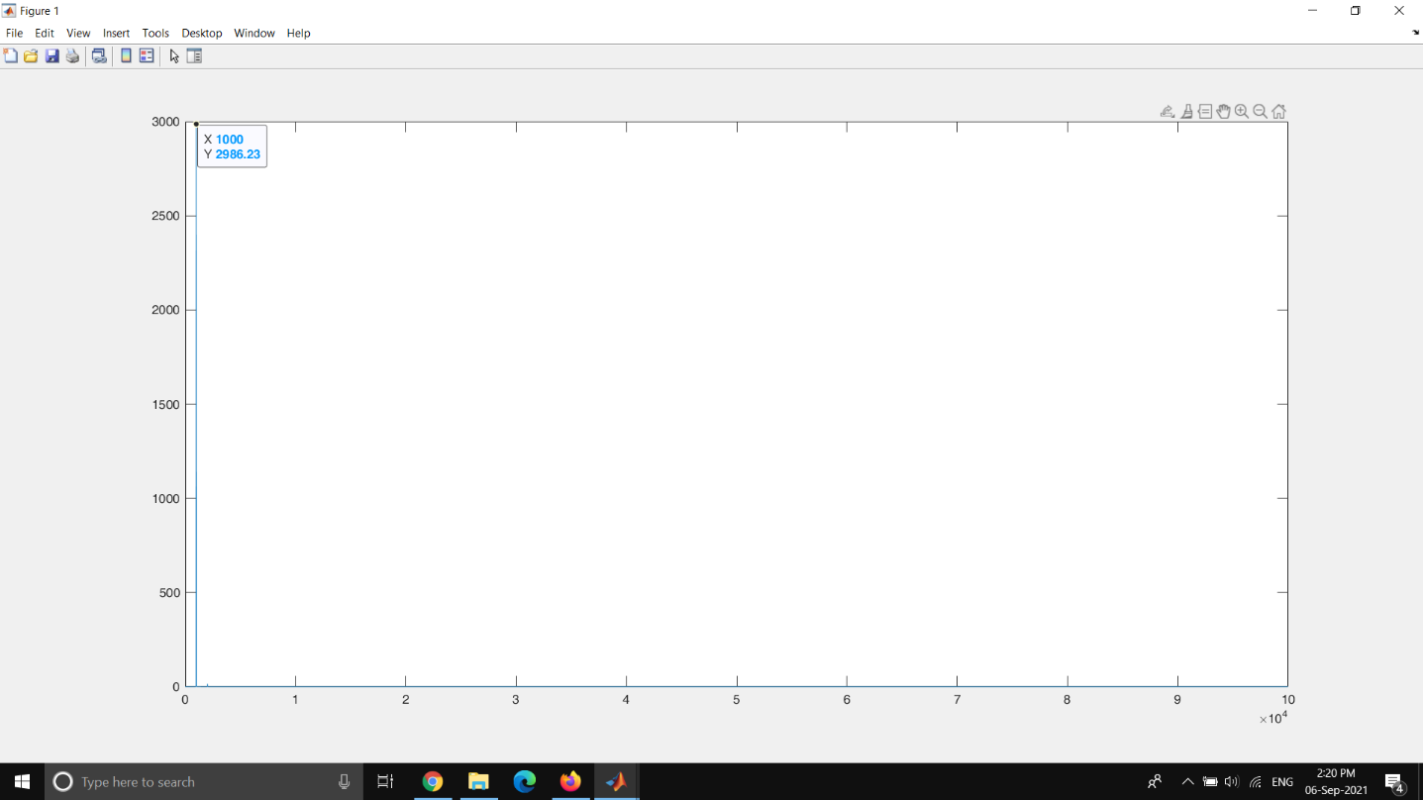

Figure 29 : FFT plot of the recovered message signal (Demodulation with differentiation)

For the square pulse

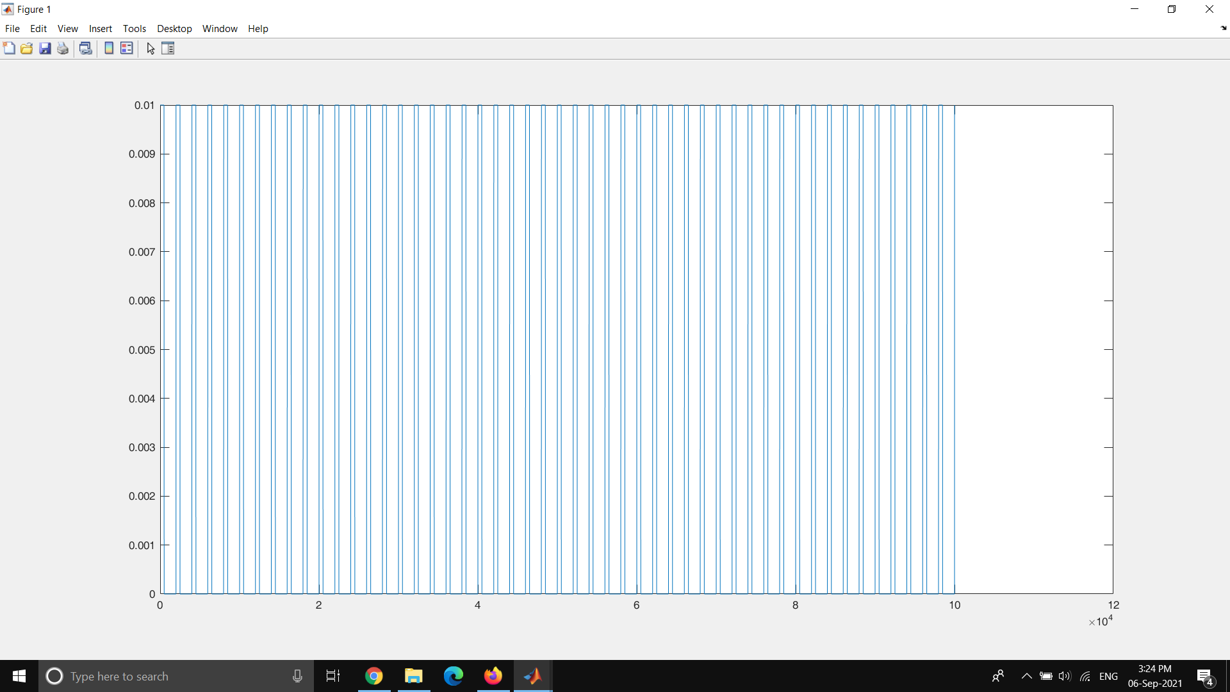

Figure 30 : Square Pulse (message signal)

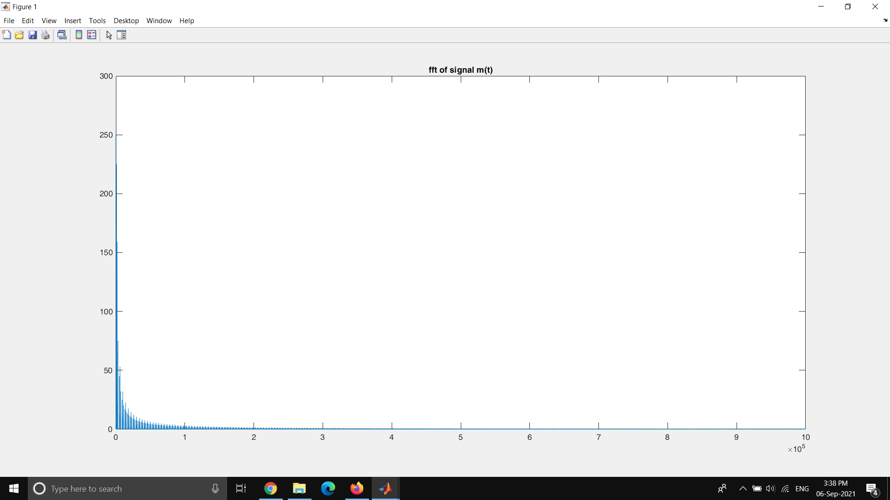

Figure 31 : FFT of the square pulse

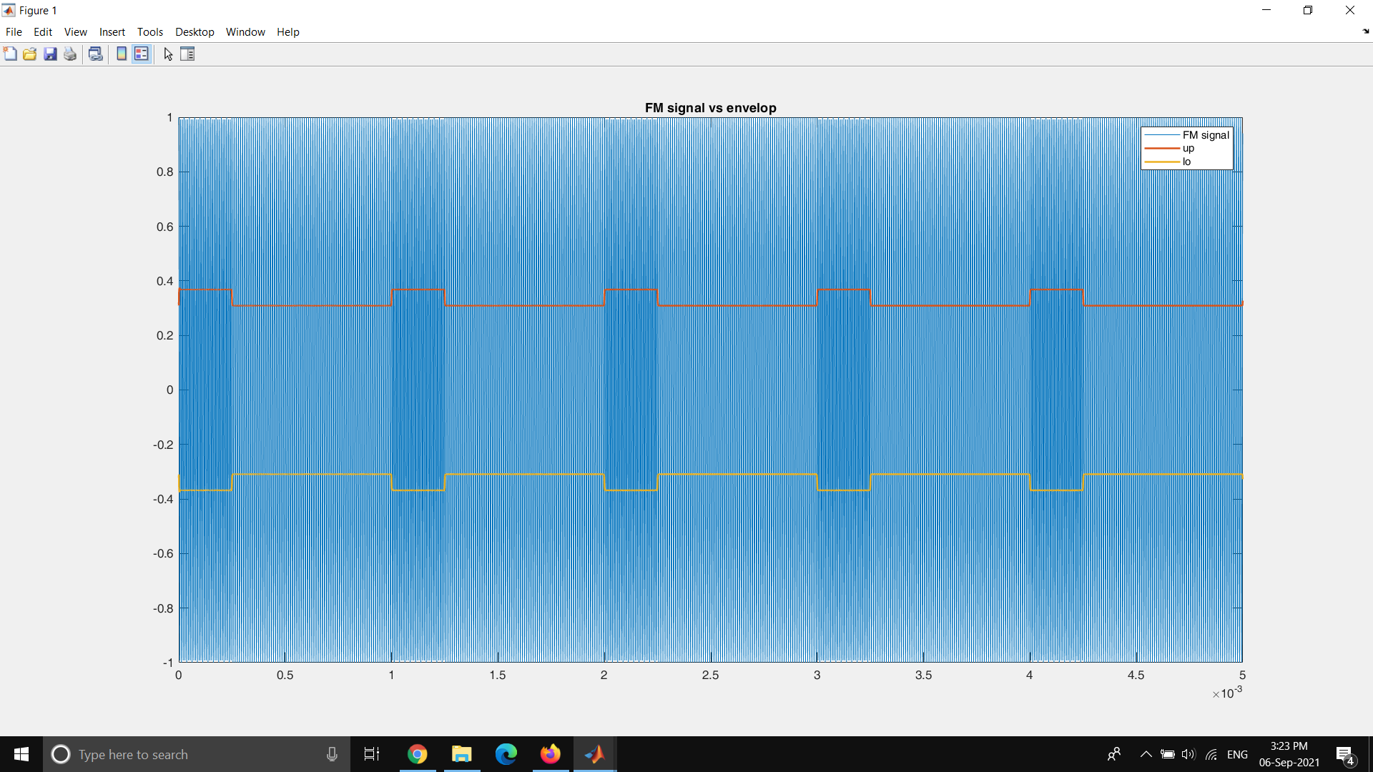

Figure 32 : Time Series plot of the FM signal vs the envelop detected

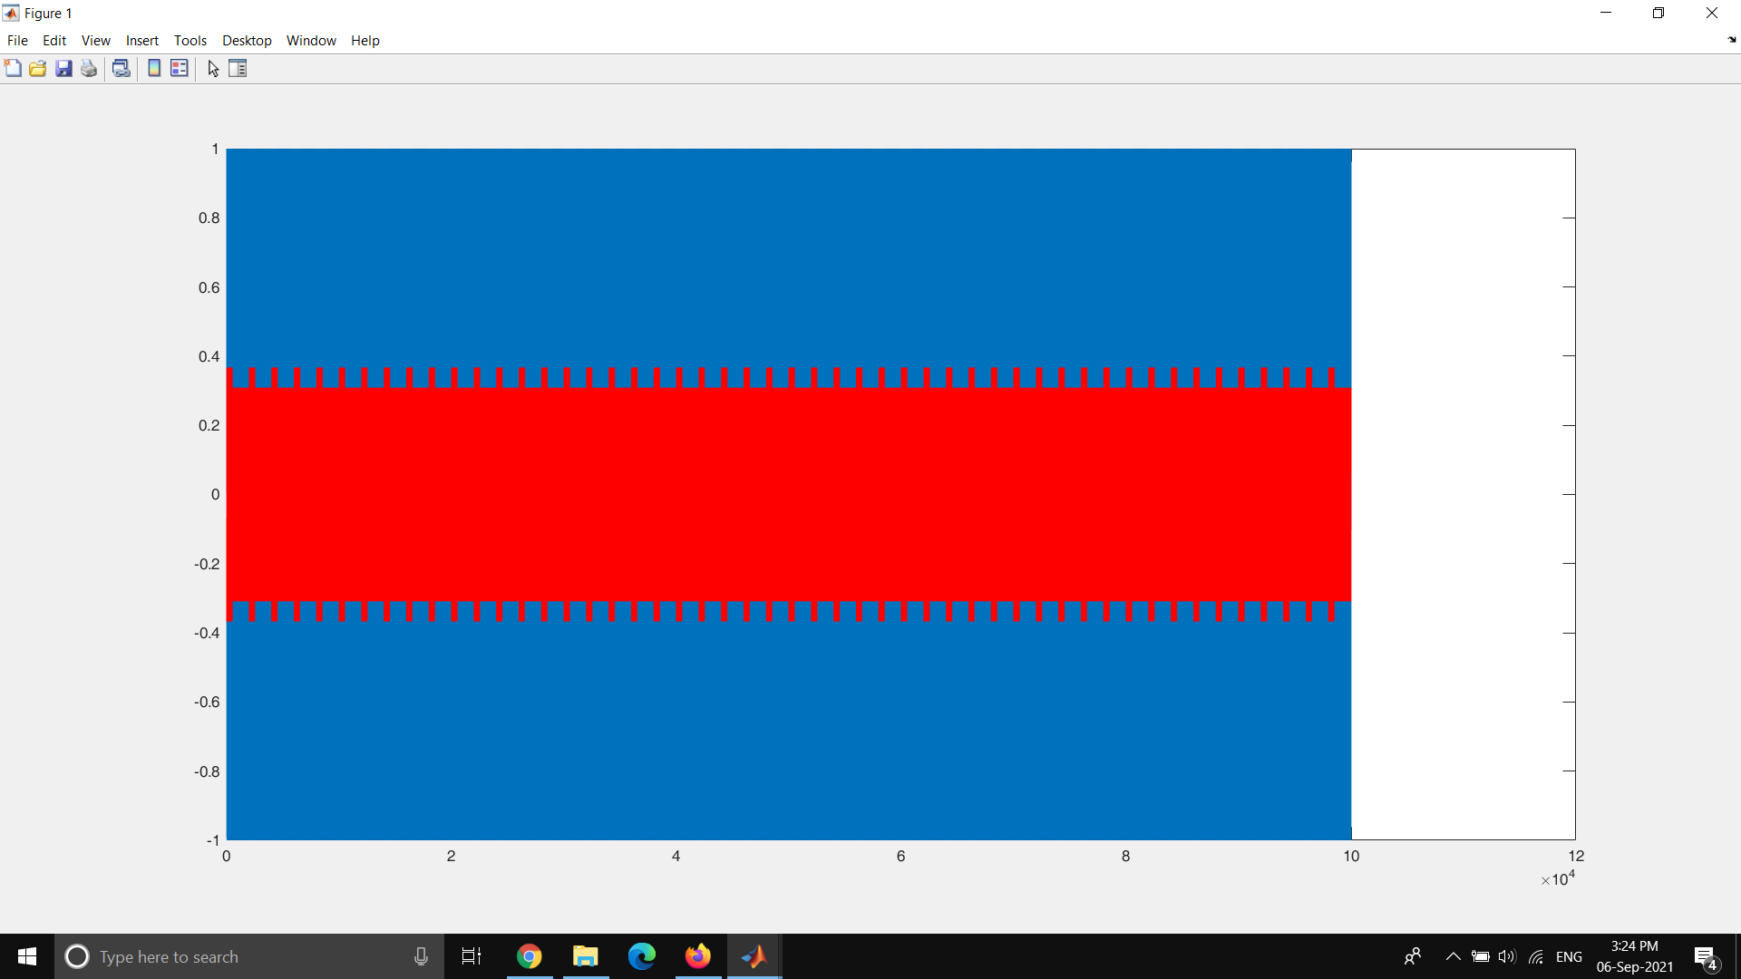

Figure 33 : Time Series plot of the FM signal and the differenciated Fm signal

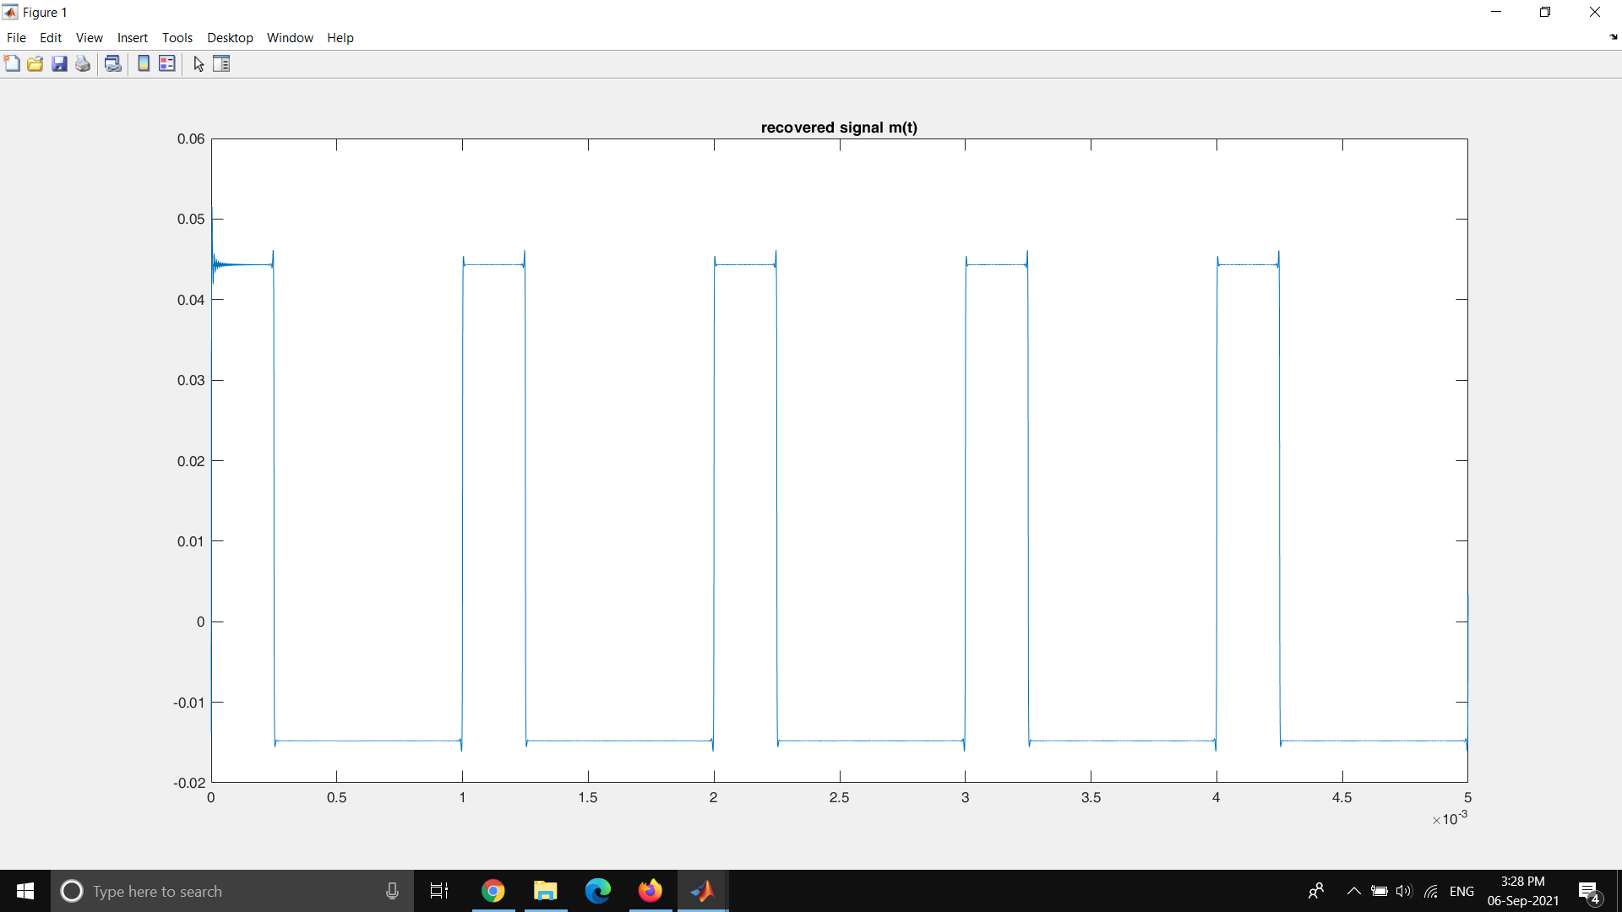

Figure 34 : Time Series plot of the demodulated message signal

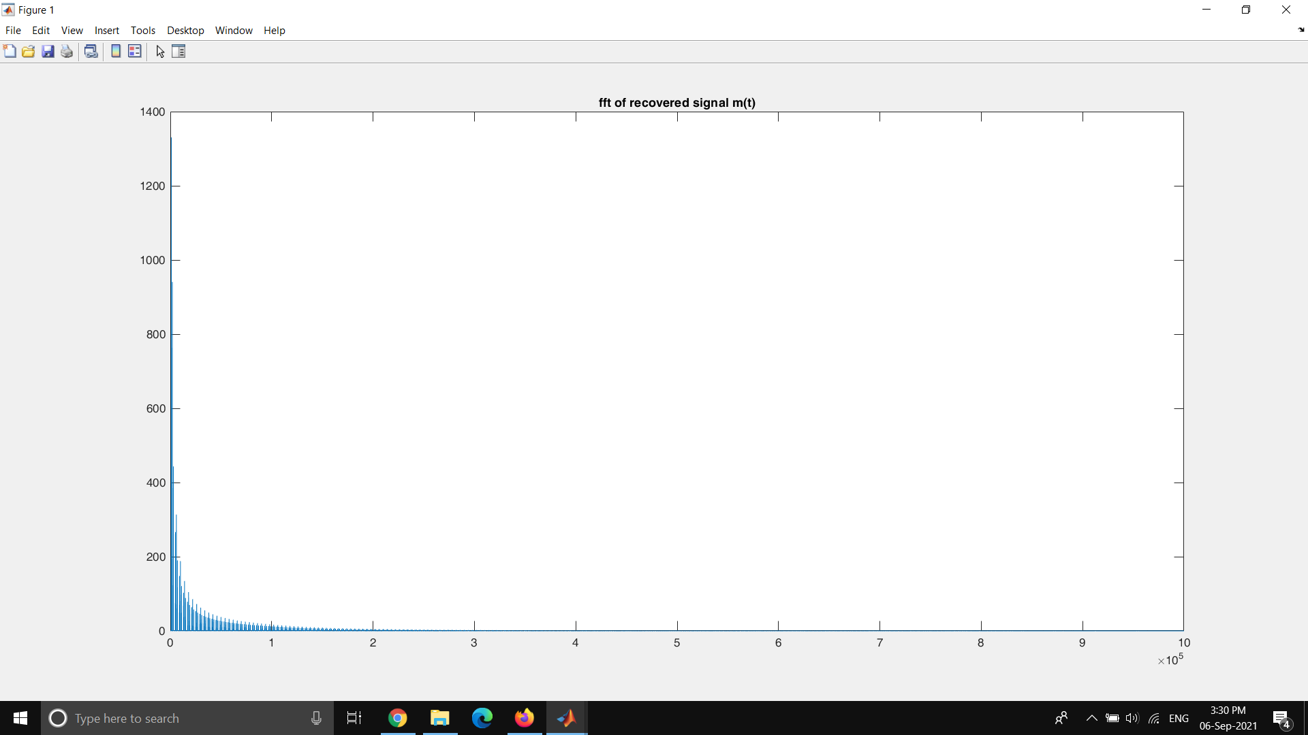

Figure 35 : FFT plot of the demodulated square pulse signal

Figure 35 and Figure 31 looks identical. This means the signal is demodulated can be assumed identical to the message signal.

**FM Arctangent Demodulation**

fm = 1000; %1kHz

fc = 100000; %100kHz

Fs = 4*fc;

L = 100000;

t = (0:L)*(1/Fs);

Am = .1;

kf = 1;

mt = Am*cos(2*pi*fm*t);

imt = cumtrapz(mt);

Xfm = cos(2*pi*fc*t + 2*pi*kf*imt);

f = Fs*(0:(L/2))/L;

y = bandpass(Xfm,[fc-500 fc+500],Fs);

xi = y.*cos(2*pi*fc*t);

xq = y.*sin(2*pi*fc*t);

i = lowpass(xi,500,Fs);

q = lowpass(xq,500,Fs);

Xtan = atan2(q,i);

Rec_M = gradient(Xtan);

b = abs(fft(Rec_M));hold on; title(['Recovered message signal when Am = ',num2str(Am),',fm=1000,2000 Hz']);

plot(f,b(1:L/2+1))

Message Signal = 0.01sin(2π*1000*t)

Carrier Frequency = 100kHz

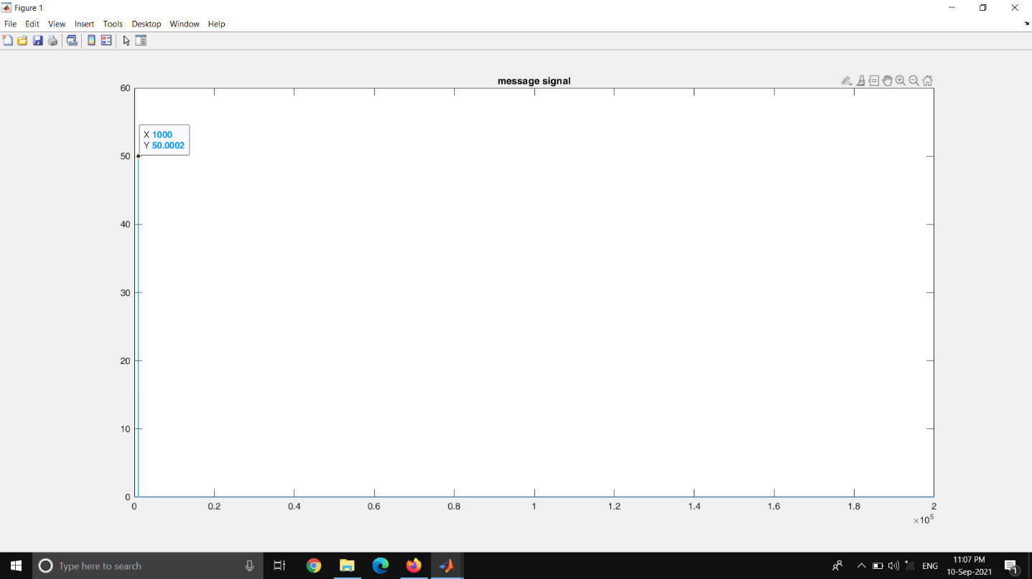

Figure 36 : FFT plot of the message signal (1kHz sinusoidal)

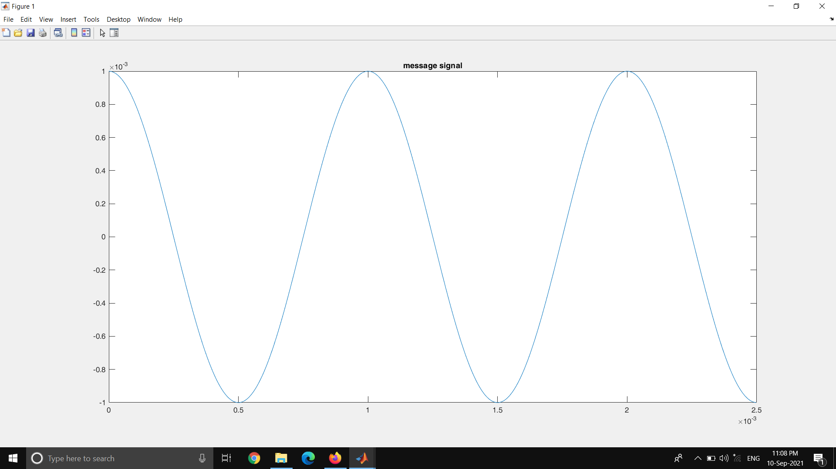

Figure 37 : Time series plot of the message signal (1kHz sinusoidal)

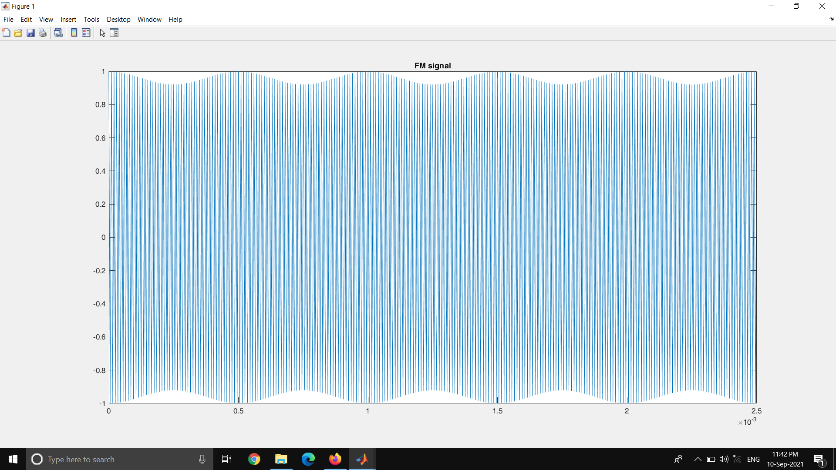

Figure 38 : Time series plot of the FM signal

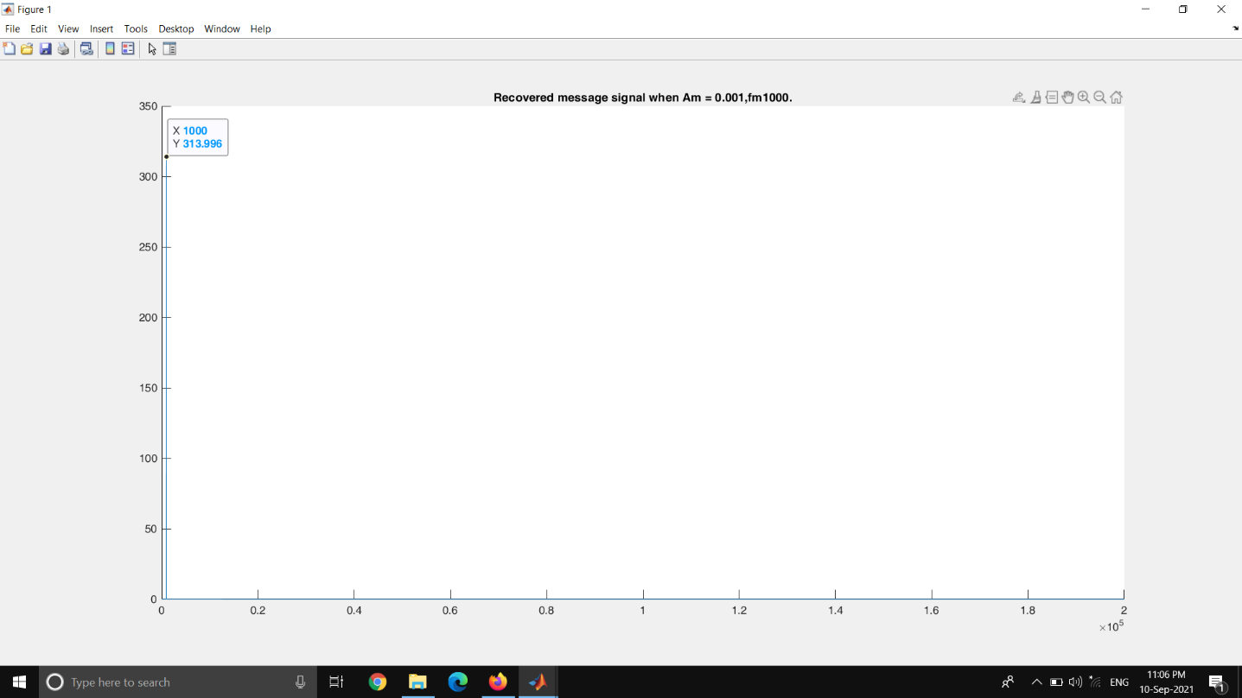

Figure 39 : FFT of the demodulated message signal (1kHz sinusoidal)

Message Signal = 0.01 * sin (2 π fm t) + 0.4Am* sin (2 π 2fm t)

fm = 1kHz

Carrier Frequency = 100kHz

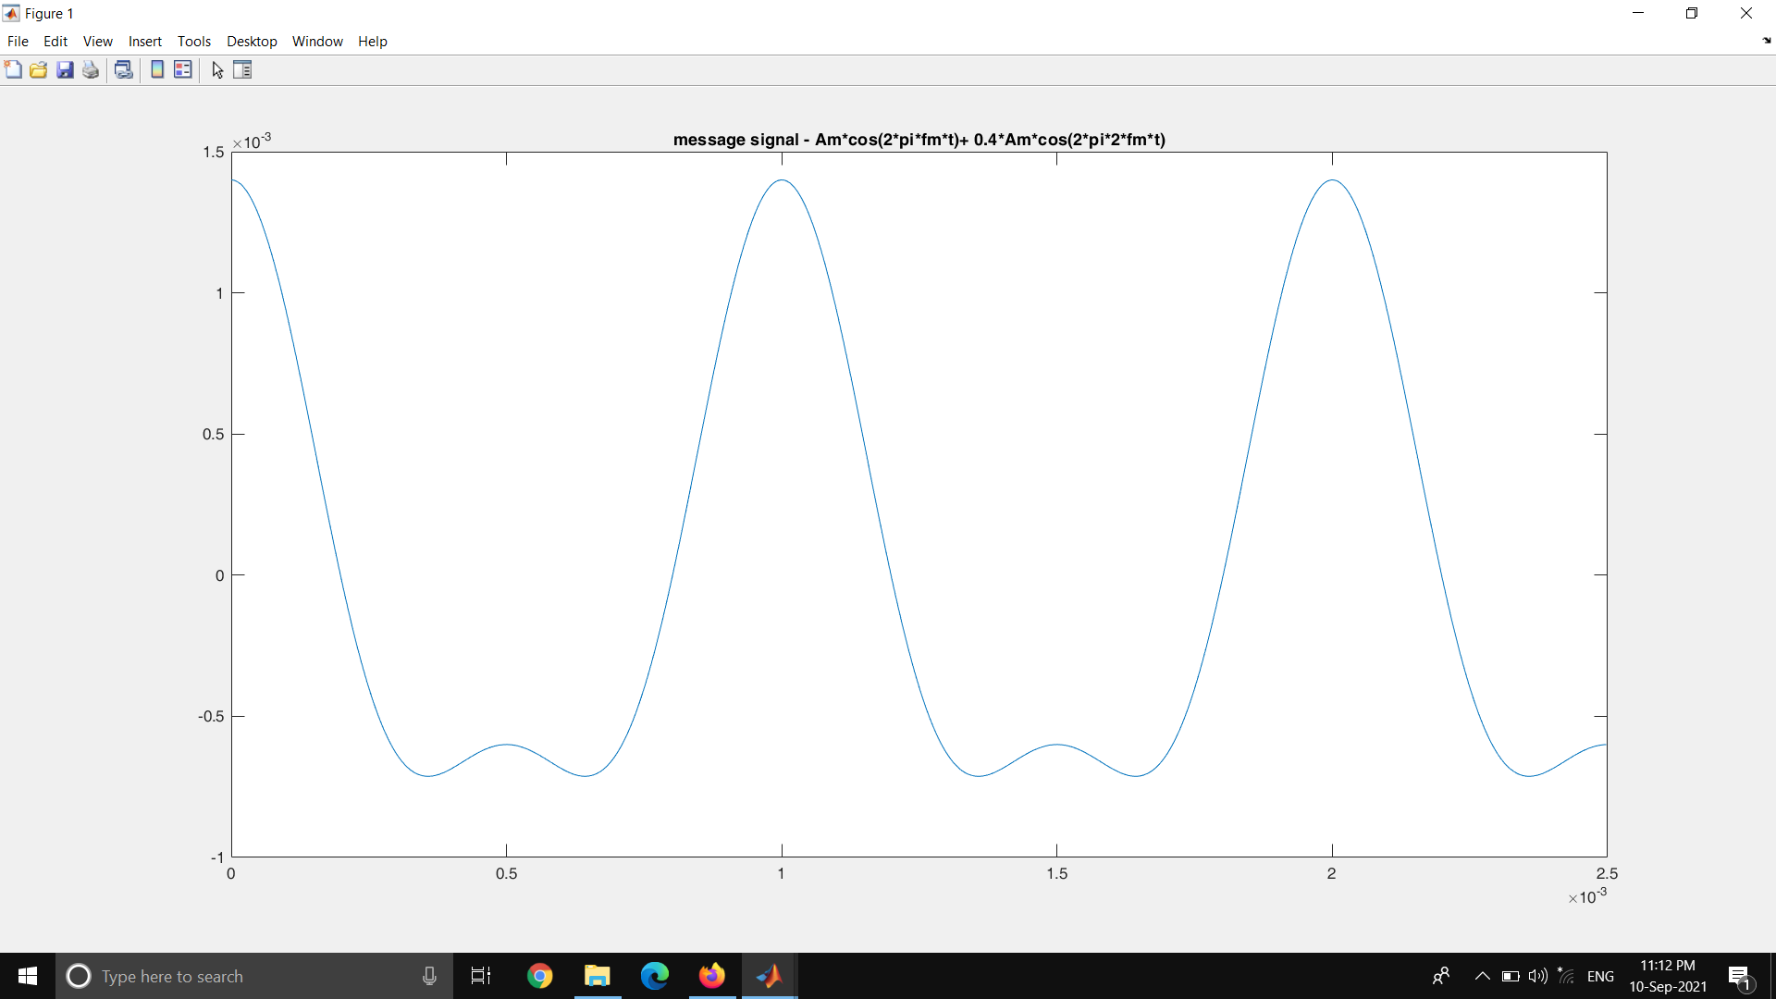

Figure 40 : Time series plot of the message signal (1kHz ,2kHz sinusoidal)

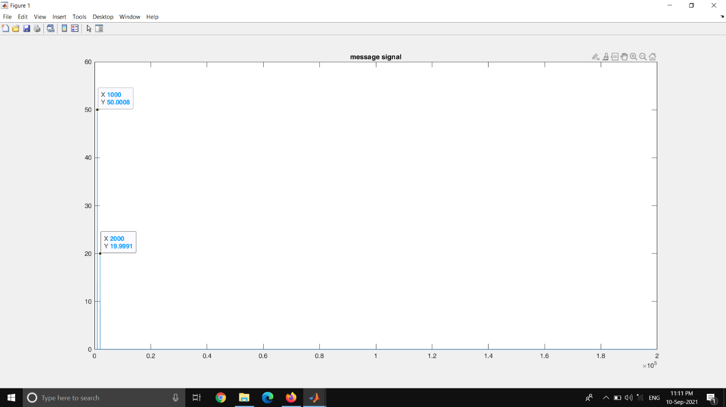

Figure 41 : FFT plot of the message signal (1kHz , 2kHz sinusoidal)

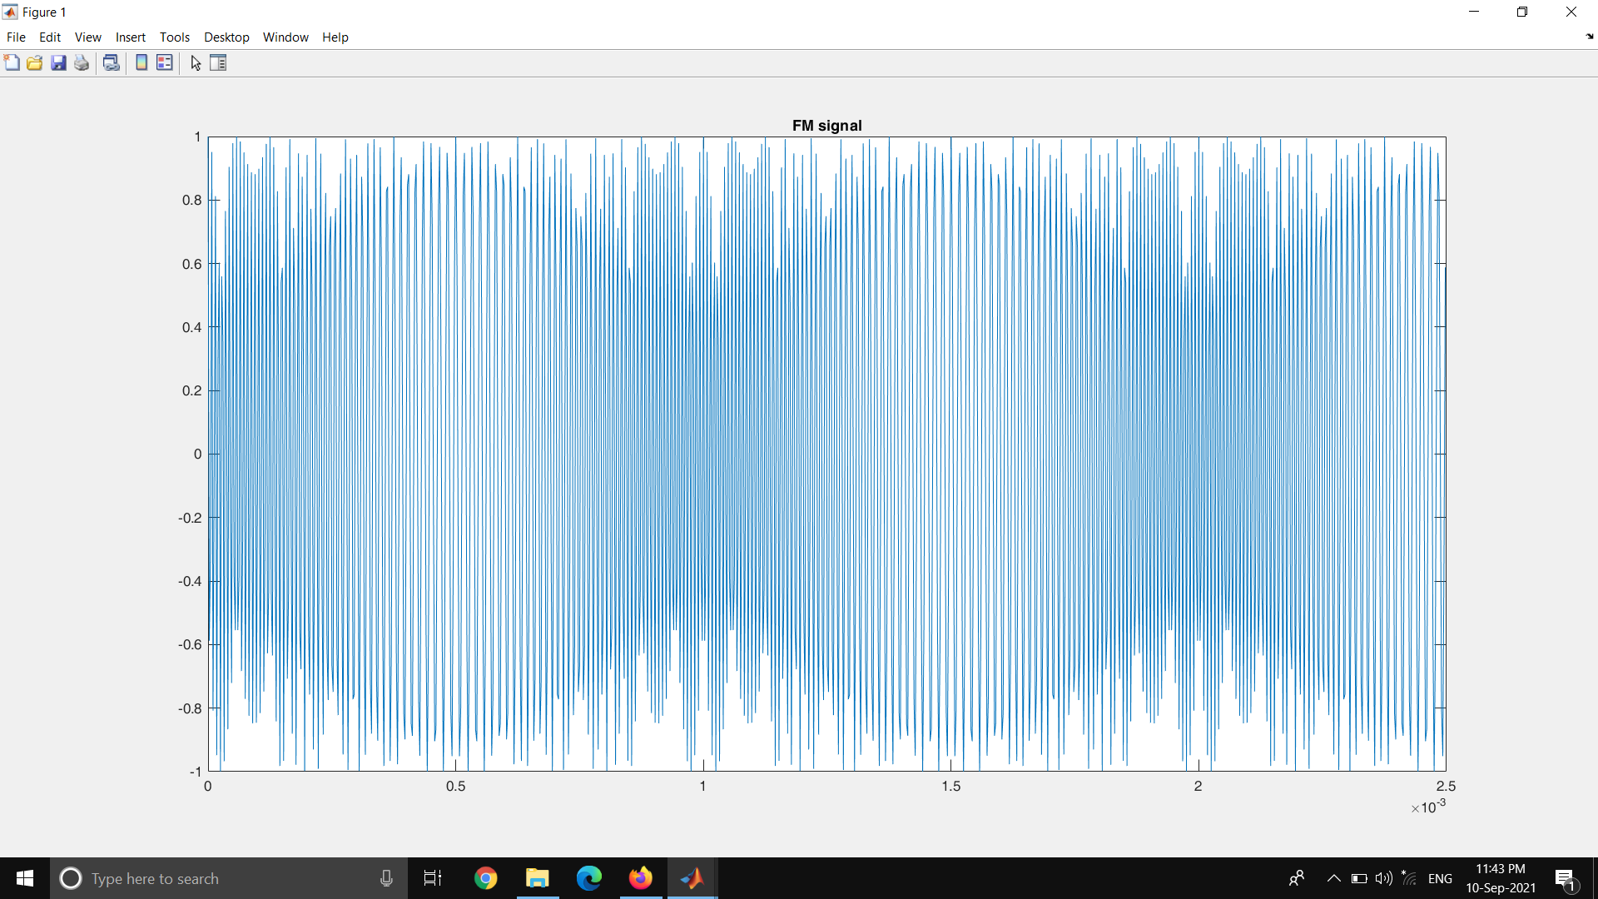

Figure 42 : Time series plot of the FM signal

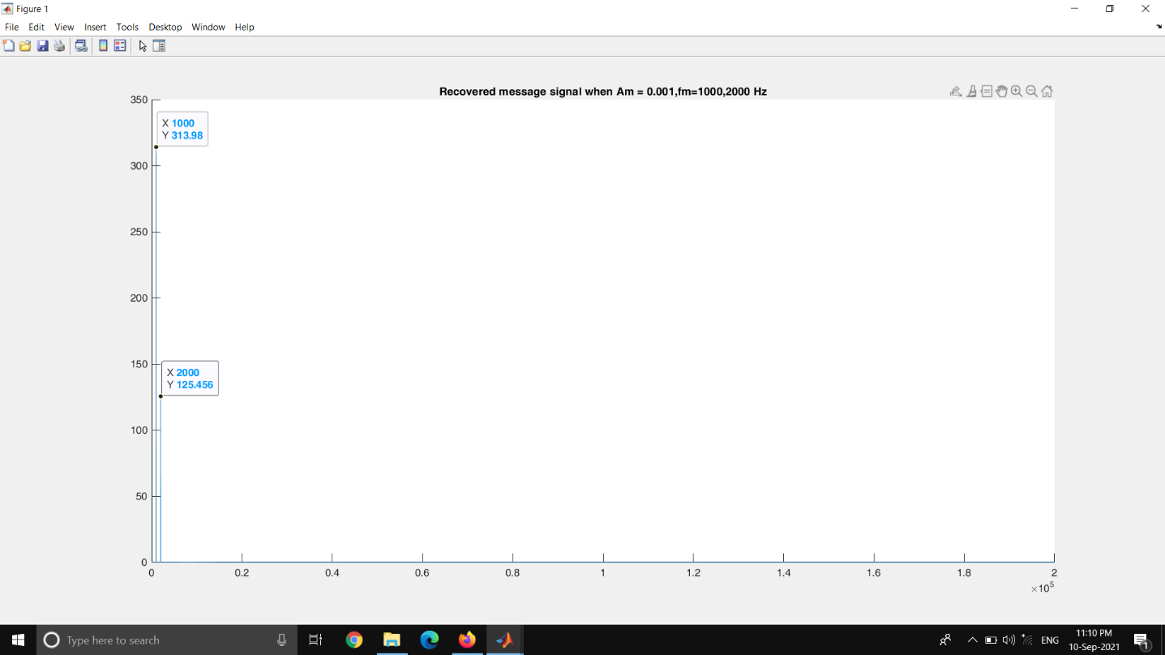

Figure 43 : FFT of the demodulated message signal (1kHz ,2kHz sinusoidal)

**FM Zero Crossing Demodulation**

fm = 25; %25Hz

fc = 300; %300Hz

Fs = 4*fc;

L = 1000;

t = (0:L)*(1/Fs);

Am = .007;

kf = 1;

mt = Am*cos(2*pi*fm*t);

imt = cumtrapz(mt);

Xfm = 2*cos(2*pi*fc*t + 2*pi*kf*imt);

f = Fs*(0:(L/2))/L;

zerCross=[];

for i=1:size(Xfm,2)-1

if(Xfm(1,i)<0 && Xfm(1,i+1)>0)

v = 1;

else

v=0;

end

zerCross=[zerCross v];

end

IndCross = find(zerCross==1);

for i=IndCross

zerCross(1,i+1)=1;

end

b=lowpass(zerCross,25,Fs);

c = abs(fft(b));

plot(f,c(1:L/2+1));hold on;title('FFT plot Recovered message signal');

Message Signal = 0.01 * sin (2 π fm t)

fm = 25Hz

Carrier Frequency = 300Hz

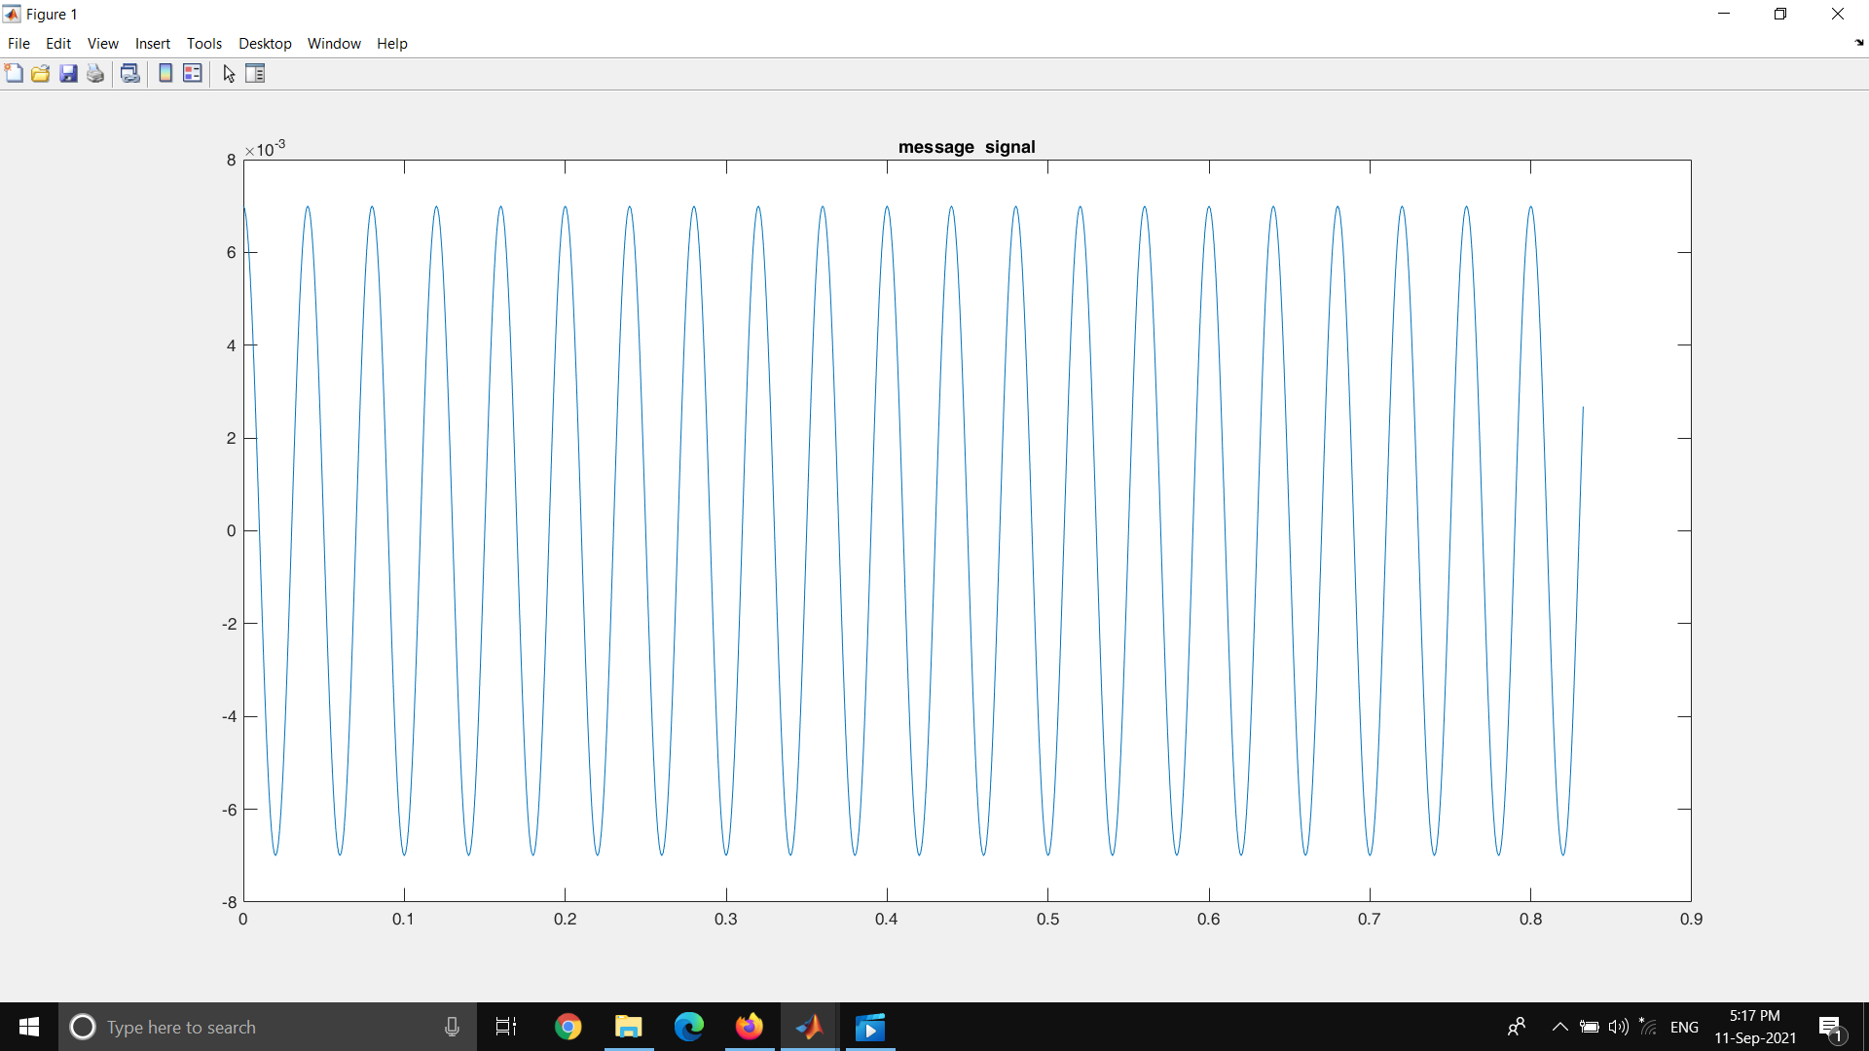

Figure 44 : Time series plot of the message signal (25 Hz sinusoidal)

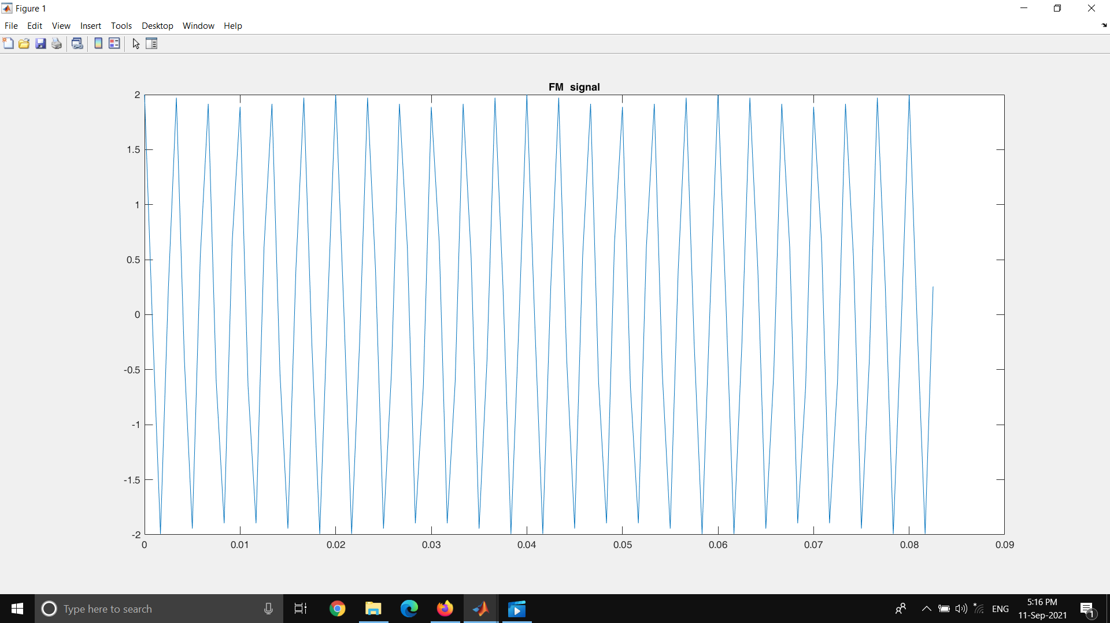

Figure 45 : Time series plot of the FM signal (25 Hz sinusoidal)

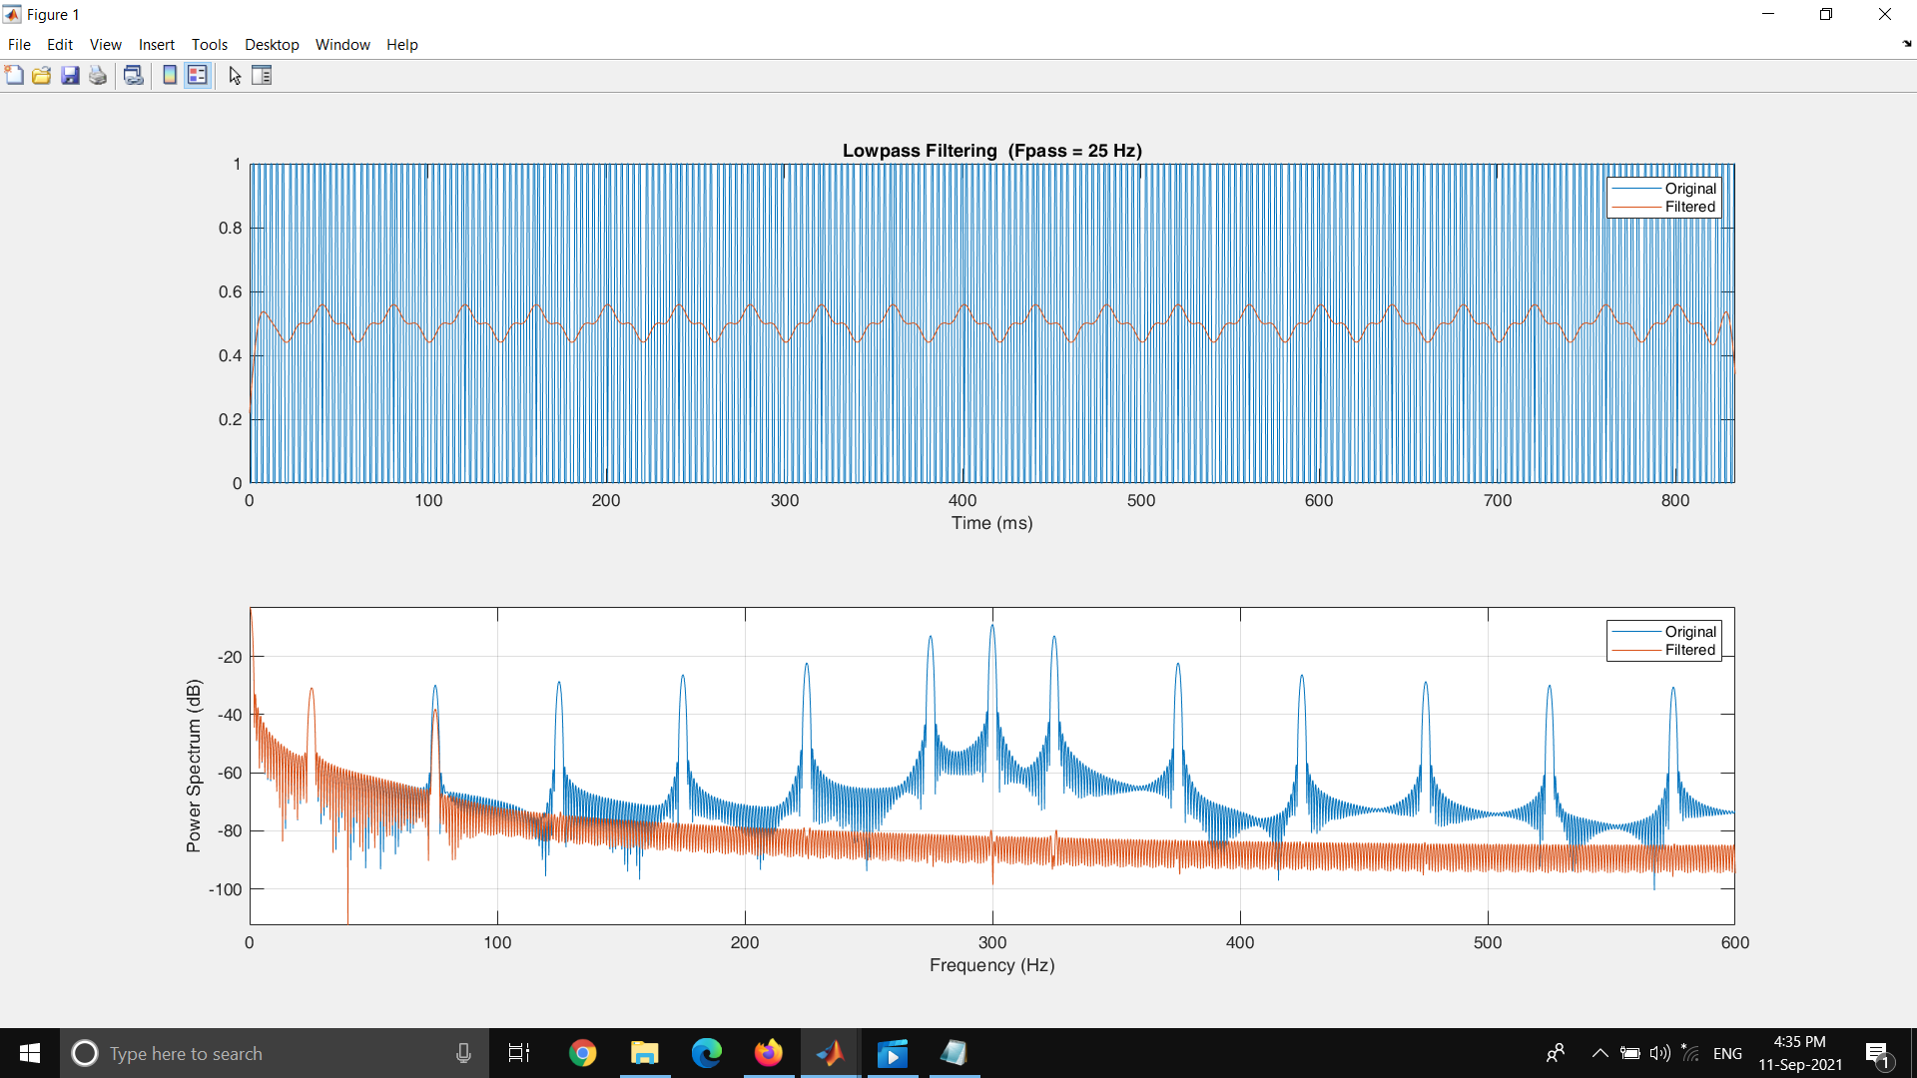

Figure 46 : Low Pass Filter

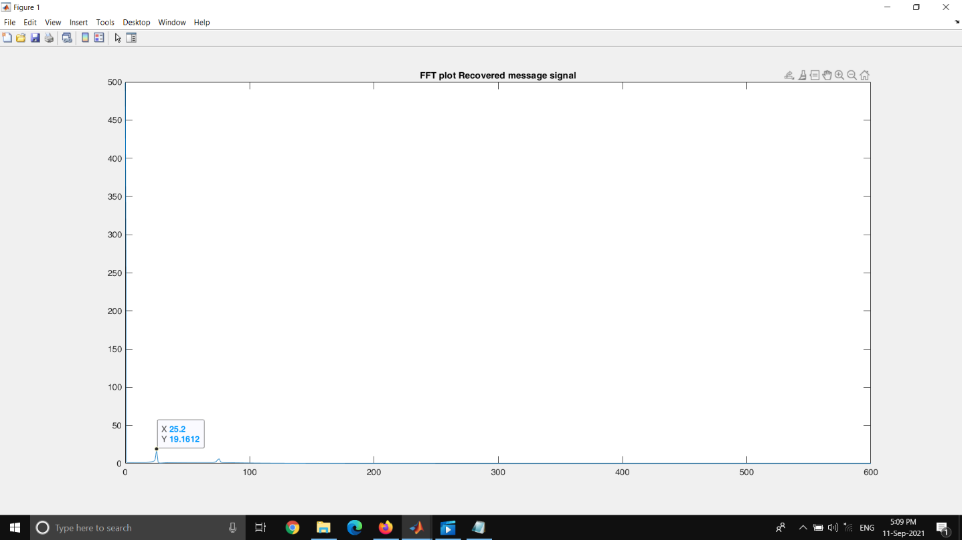

Figure 47 : FFT plot of the demodulated message signal (25 Hz sinusoidal)

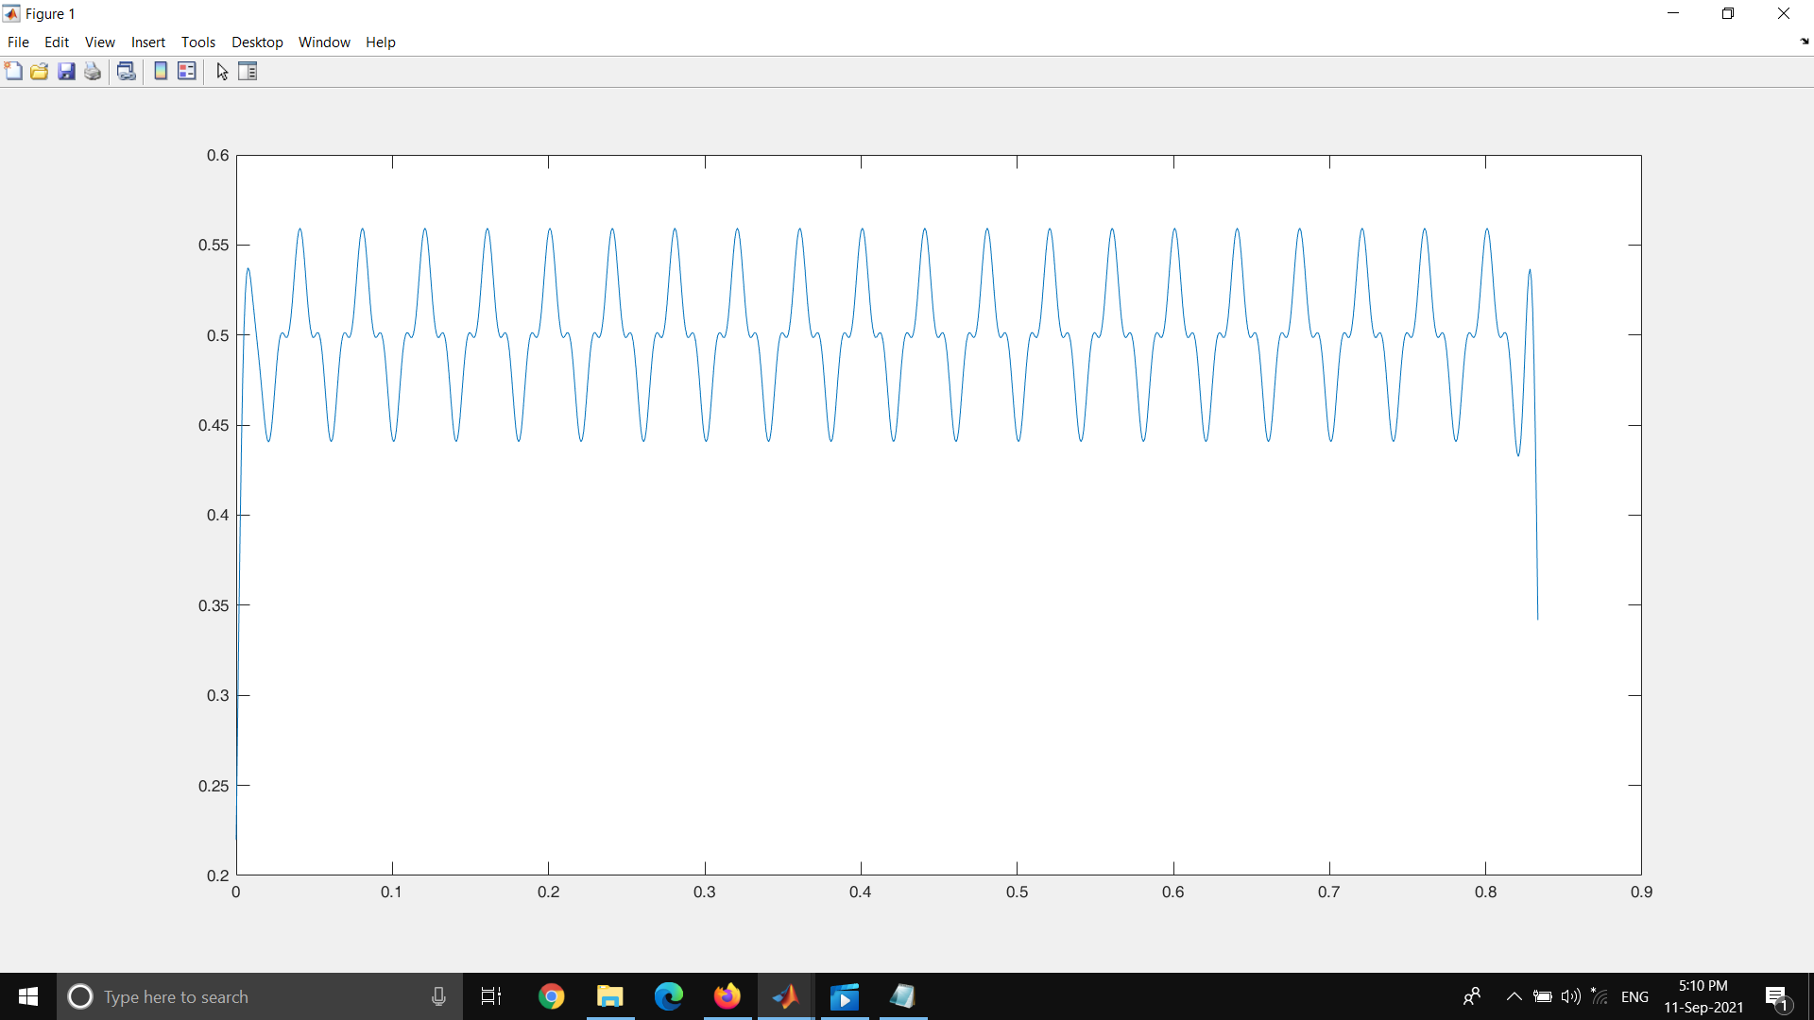

Figure 48 : Time series plot of the demodulated message signal (25Hz sinusoidal)

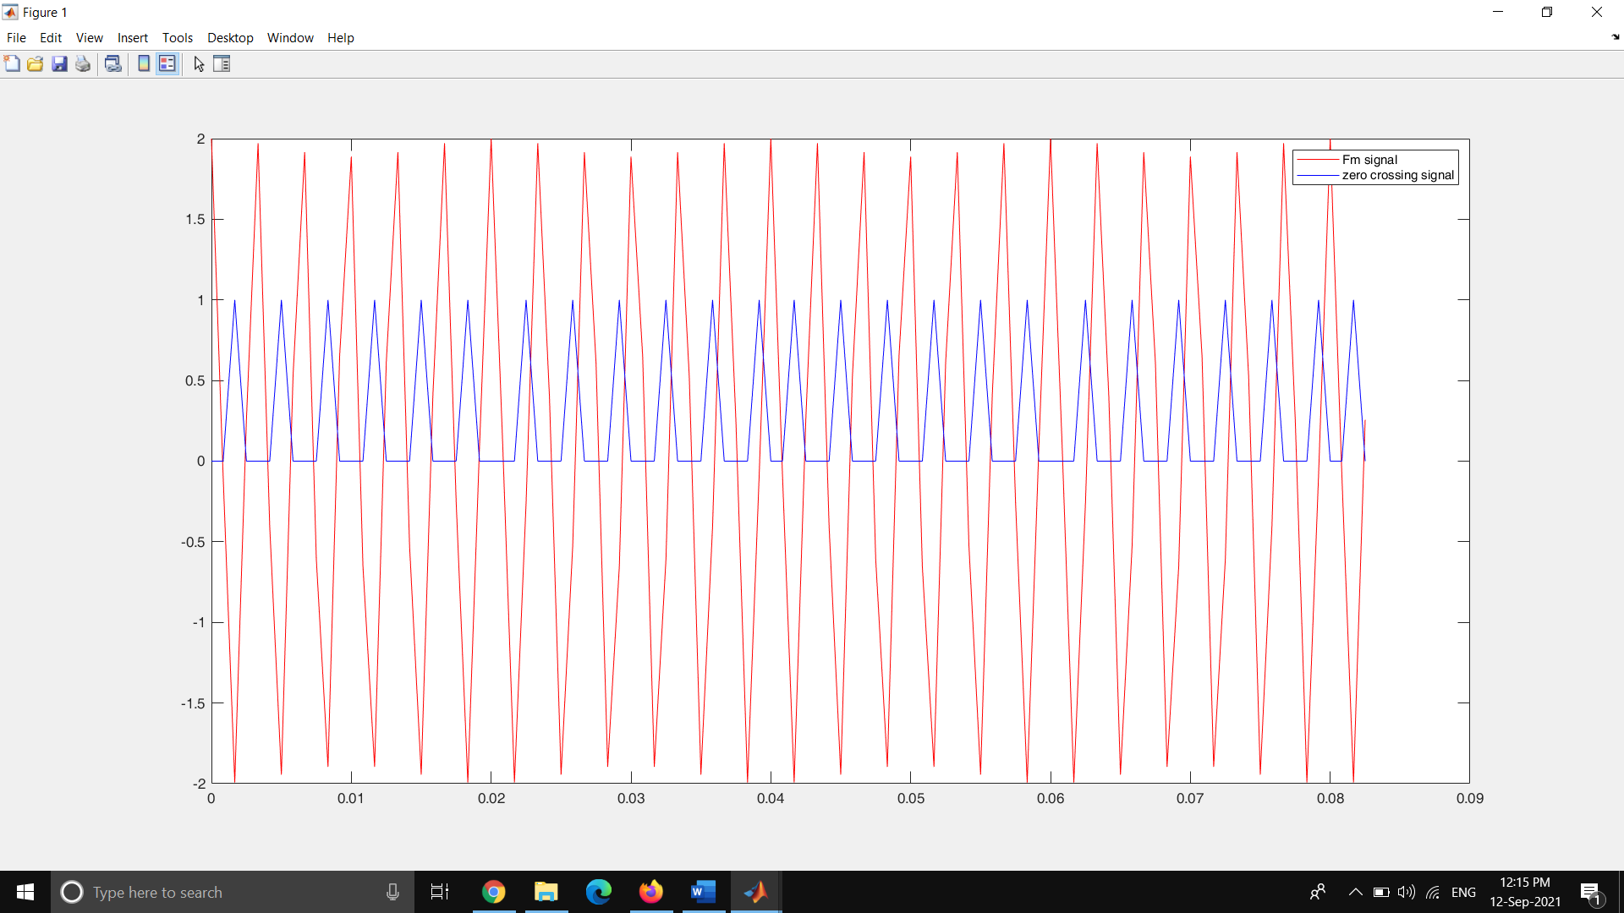

Figure 49 : FM signal vs the Zero crossing points

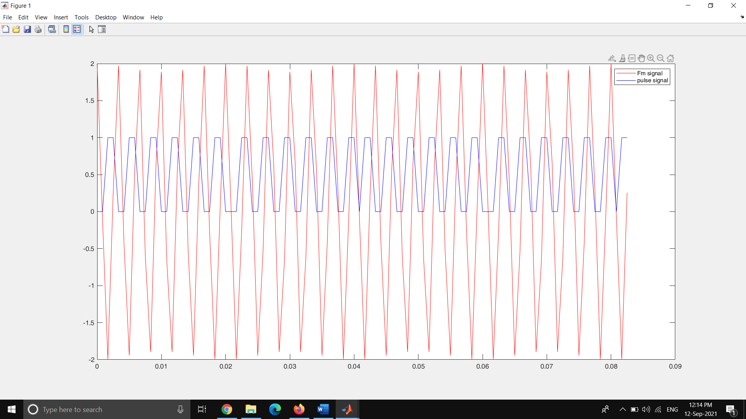

Figure 50 : FM signal vs the Pulse train